 |  |  | Operating instructions | 

Work - Equipment - Apparatus - Device
Dithiothreitol

Dangers for humans and the environment
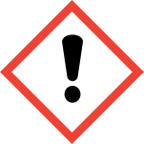 |  | Safety data sheet from Sigma-Aldrich, Version 5.3, 14.10.2013  Signal word: [Caution!]  Classification according to EU Directives 67/548 / EEC or 1999/45 / EC  Harmful if swallowed. Irritating to the eyes, respiratory system and the  Skin.  Hazard statements (H-phrases)  H302 Harmful if swallowed.  H315 Causes skin irritation.  H319 Causes serious eye irritation.  H335 May cause respiratory irritation.  Safety instructions (P-phrases)  P261 Avoid breathing dust / fume / gas / mist / vapors / spray.  P305 + P351 + P338 IF IN EYES: Gently use for several minutes  Rinse water. Remove contact lenses, if possible.  Continue rinsing.

Protective measures and rules of conduct
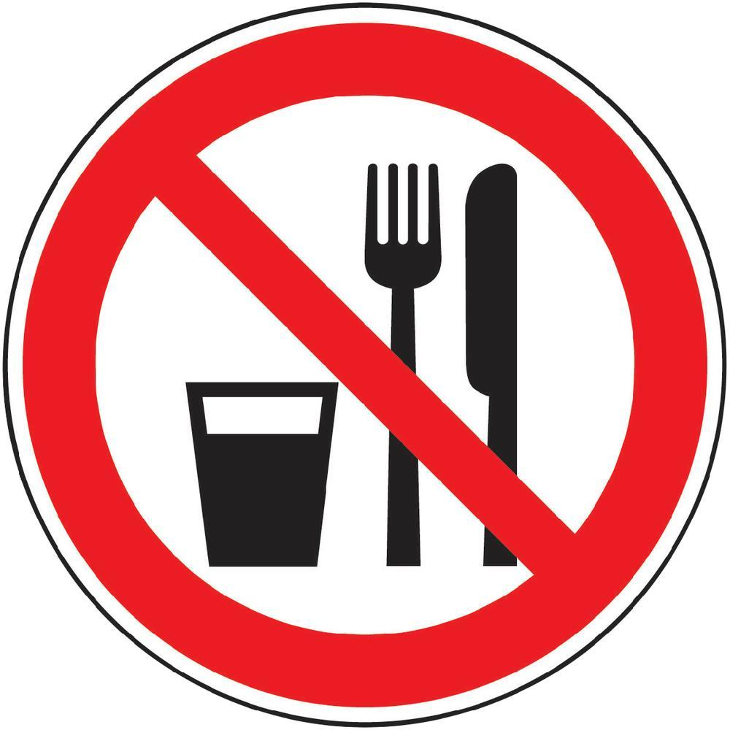  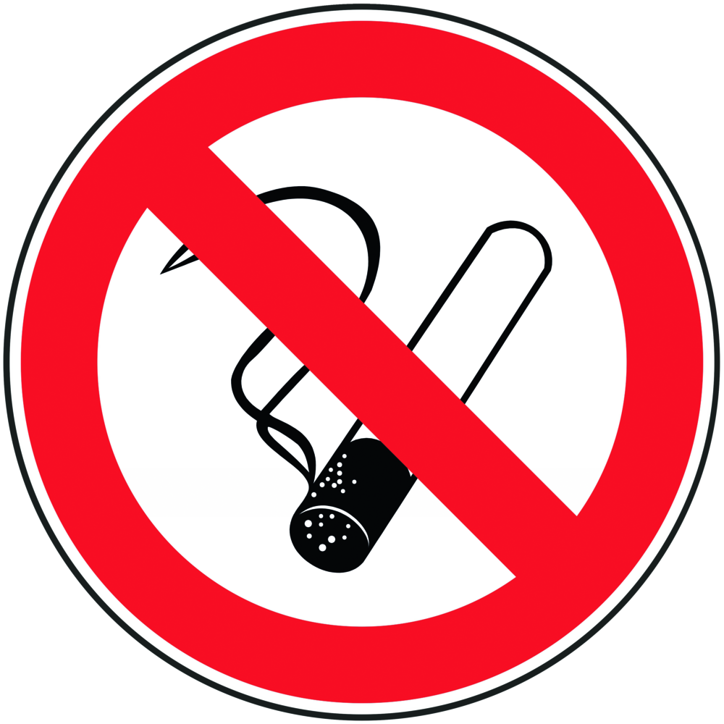 | General information  - Eating, drinking or smoking is prohibited in all laboratory facilities!  - Avoid contact with eyes and skin. |  |  |  |  | - pE

Personal protective measures
Avoid contact with eyes and skin.
Avoid dust and aerosol formation. In case of dust formation for suitable ventilation
to care. During laboratory work, always wear a laboratory coat.
Eye / face protection:
Safety glasses with side protection

Skin protection:
Work with gloves.
Material: nitrile rubber
Minimum layer thickness: 0.11 mm
Breakthrough time: 480 min

In case of dust formation:
Respirator: FFP2 particle filter

Use and storage
Store in a cool place. Keep container tightly closed in a dry, well-ventilated place.
Recommended storage temperature: 2 - 8 ° C

Disruptions and Dangers
 | In case of fire:  Suitable extinguishing media: water spray, alcohol-resistant foam,  Use dry chemical or carbon dioxide.  Special hazards arising from the substance or mixture  Carbon oxides, sulfur oxides, hydrogen sulphide  In case of fire, wear self-contained breathing apparatus, if necessary.  Personal precautions, protective equipment and in case of emergency  Procedures to be used:  Use personal protective equipment. Avoid dust formation. Vapors / mist / gas  do not breathe. Ensure adequate ventilation. Bring people to safety. The  Avoid inhalation of dust.  If spilled:  Absorb dust-free and deposit dust-free. Return and shovel up. to  Dispose of in suitable and sealed containers.

Accidents and First Aid
 | In general notes:  Consult a doctor. Show this safety data sheet to the attending physician.  After inhalation::  If inhaled, remove affected person to fresh air. In respiratory arrest,  artificial respiration. Consult a doctor.  after skin contact:  Wash with soap and a lot of water. Consult a doctor.  After eye contact:  Rinse thoroughly with plenty of water for at least 15 minutes and consult a doctor.  After swallowing:  Never give anything by mouth to an unconscious person. Mouth with water  Rinse. Consult a doctor.  Most important symptoms and effects, both acute and delayed  Nausea, headache, vomiting, central nervous system depression ("According to our  Knowledge is the chemical, physical and toxicological properties  not been extensively studied. ")

Tests - Maintenance - Disposal
Add residues and non-reusable solutions to the chemical disposal.

Signatures
Supervisor: Signature:

Town: Date:

