 |  |  | Operating instructions | 

Technical Equipment – Devive – Machine - Tool
Digestor

Environmetal and health Hazards
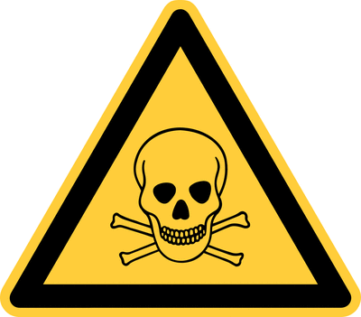  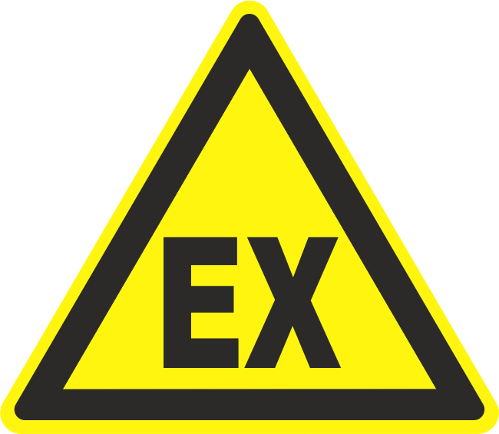 | - Danger of explosion or fire if flammable gases, vapors, dusts or aerosols are released (alcohols and solvents may form explosive vapor / air mixtures at room temperature).  - Risk of inhalation (harmful) gases, vapors, dusts and aerosols with reduced or insufficient withdrawal rate.  - Stirring, mixing, etc., leads to faster evaporation of flammable liquids.  - Danger of injury from the spraying of hazardous substances or flying parts when the sash is open.  - Risk of the sash falling when the rope breaks.

Safety Precautions
  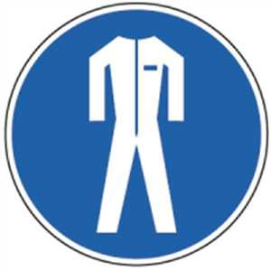 |  | Wear necessary PPE: eye protection, hand protection, respiratory protection, lab coat.  Only use work equipment as instructed by the responsible laboratory manager.  Check the function of the trigger before starting and during the work (green LED: Pull-off power ok, red LED and warning signal: Pull-off power not ok).  In laboratory fume hoods with insufficient performance, do not work with toxic and very toxic substances.  Turn on the trigger a few minutes before starting work.  When opening / closing the sash, a strong draft may occur in the short term, causing vessels to tip over. Therefore, fix vessels or place them close to the exhaust wall.  Always keep sash closed except during bodywork.  Only work on the work surface and do not overfill it. The air intake openings must always remain free.  Avoid large substance releases.  Keep unnecessary objects away from the interior.  Keep the thermal load (eg. through the burner) as low as possible. The digester, which stores toxic chemicals and chemical waste, is used exclusively as a warehouse. This may not be used for other work! Use only after consultation with the laboratory manager!  After completing all work and before switching off the trigger, close all open containers and remove all unnecessary materials from the trigger. |  |  |  | - pE

Malfunction and associated risks
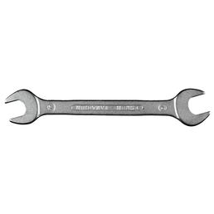 |  | In case of stiffness or misalignment of the sash, stop work and contact the responsible person.  In the case of an alarm display or error message, stop the activity with the risk potential in a controlled manner and immediately stop working in the fume hood.  Immediately report any faults to the laboratory supervisor

In the event of an accident
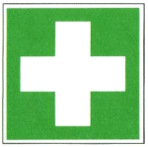 |  | First care for minor injuries.  In case of major injuries contact the doctor.

Serving – Maintenance - Disposal
Have regular, annual inspection, maintenance and if necessary repairs done.

Signatures
Group leader / Supervisor: Signature:

Town: Date:

