 |  |  | Operating instructions | 

Technical Equipment – Devive – Machine - Tool
Device working with pressurized air

Environmetal and health Hazards
 | - If not securely locked, lids of pressure chambers may be displaced when pressure rises  - Devices under pressure not handled properly may break and result in heavy parts flying around  - Plant material may be shot out of pressure chambers  - Accidental release of pressurized air may propel pressure cylinders

Safety Precautions
 |  | - The devices may only be operated by trained staff  - Never use devices with compressed air when alone at the department  - Prior to any use, all parts of the device including and particulary the hoses have to be visually inspected. Do not use, if you encounter signs of mechanical damage or corrosion  - Keep the pressure cylinder in a place where it can be fastened or put down, so it can´t topple over by accident  - Check the maximum pressure of the devices (some devices look the same but have different limits)  - Pre-set the first (left) pressure adjustment handle of the double stage regulator to a value slightly higher than needed for the intended measurement but never higher than the limit of the device  - Keep the devices clean and lubricate the O-rings if necessary  - Protect your eyes. If possible use a binocular or digital magnifier with Scholander devices  - If bayonet-type lids of pressure chambers do not click into place with a light push and turn, do not proceed.  - Prior to increasing the pressure, check if the yellow marks on the chassis and the lid of the pressure chamber overlap  - Increase pressure slowly  - Close main valve (of the pressure cylinder) whenever pressure is not needed  - Do not uncouple the quick-disconnect fittings while hose is under pressure. Always check hose and instrument gauges for zero pressure before operating quick-connect fittings.  - After measurements, release pressure from system. |  |  |  | - pE

Malfunction and associated risks
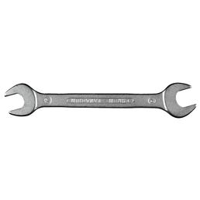 |  | - If unexpected behavior of a device arises, immediately lose the main valve  - In case of unusual occurrences or observations attach a warning sign to the device and do not use it until it is thoroughly checked  - Faults must be reported to the working group leader who must provide consent prior to repair or service

In the event of an accident
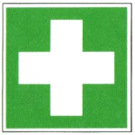 |  | - Clean open wounds and apply disinfectant  - If necessary call a doctor  - Inform the working group leader

Serving – Maintenance - Disposal
- The devices have been serviced according to the service plan

Signatures
Group leader / Supervisor: Signature:

Town: Date:

