 |  |  | Operating instructions | 

Technical Equipment – Devive – Machine - Tool
Cutting tools

Environmetal and health Hazards
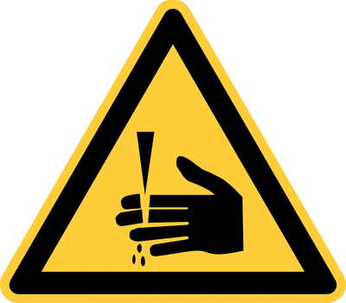 | - Danger of cutting accidents

Safety Precautions
 |  | - Do not leave blades and knives lie about unattended  - Do not throw blades into garbage bin – cleaning persons may hurt themselves  - If cutting under water, change water frequently  - If carrying knives and blades, do not run and hold them with the blade facing the floor |  |  |  | - pE

Malfunction and associated risks
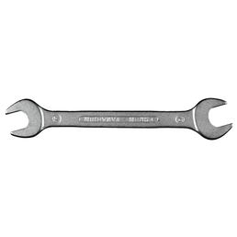 |  | - Rusty or non-honed cutting devices will work less reliably and thus provoke accidents

In the event of an accident
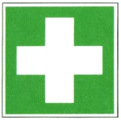 |  | - Clean open wounds and apply disinfectant  - If necessary call a doctor  - Inform the working group leader

Serving – Maintenance - Disposal
- Hone carving knives prior to use
- Dry blades, knives and secateurs after use in water and keep dry
- Use a cut resistant pad for cutting
- If blades do not cut properly, discard them immediately
- Do not throw blades in garbage bin – collect them in container for broken glass and blades

Signatures
Group leader / Supervisor: Signature:

Town: Date:

