 |  |  | Operating instructions | 

Method
Controlled Cooling

Dangers for humans and the environment
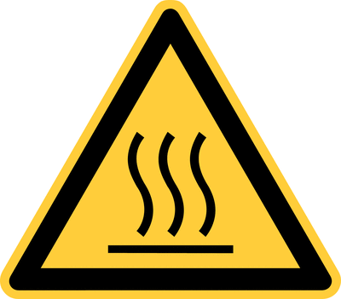  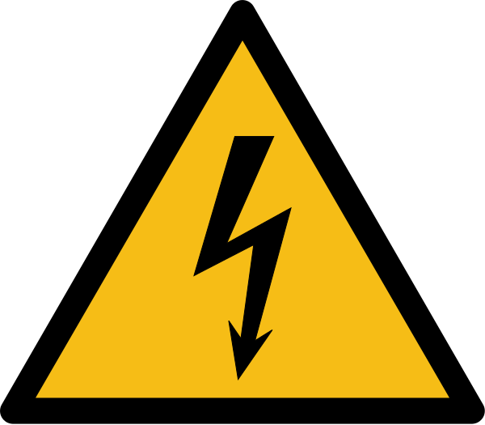    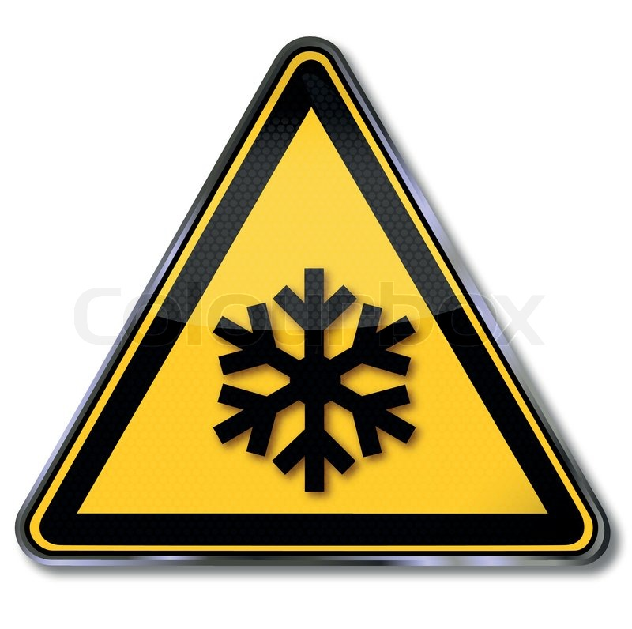 |  | • Risk of injury, especially to fingers or the scalp, due to the rotor blades of the fans in the freezer  cabinets (fans)  • Risk of eye injury from parts splitting from the rotor blades  • Risk of frostbite by touching the inner walls of the freezer cabinets and by touching components or  exhibits located in the freezer cabinets.  • Risk of skin burns by touching the PTC heating elements inside the freezer cabinets.  • Risk of fires due to contact of flammable or explosive substances with the PTC heating elements  • Danger of dangerous electric shocks by touching uninsulated, live cables.  • Risk of cuts during sample preparation when using razor blades

Protective measures and rules of conduct
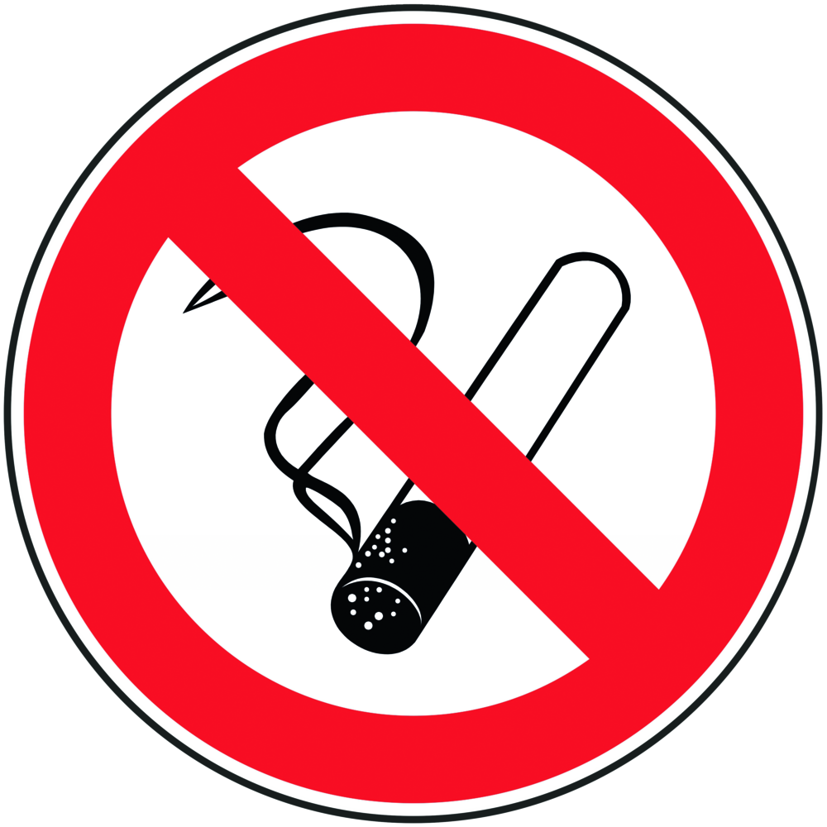  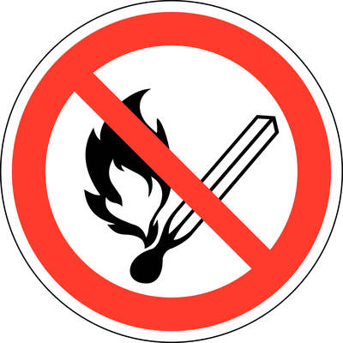   | General information  • A briefing on how to use the laboratory freezers is essential before use.  Operating instructions of the manufacturer are available in the respective  laboratory and are to be studied before use.  • Follow and comply with hazard warnings, protective measures and rules  of conduct such as those contained in the laboratory freezers and freezer controls.  • In the case of addition of INA bacteria for controlled ice nucleation,  the operating instructions for working with microorganisms and King's B medium  and culture of Pseudomonas syringa van Hall 1902 should also be considered  • When working with biological specimens, pay attention to any toxicity  . Safety measures should be adjusted accordingly.  • The system must not be operated unattended.  • During operation of the system, sufficient ventilation of the room must be provided  • No flammable or easily flammable or even explosive substances may be stored  or exposed in the freezer cabinets and their surroundings.  • No food may be stored in the freezer cabinets.  • Before opening the freezers, the fans in them must be switched off and  the power supply to the PTC heating elements must be interrupted (power "off").  • Malfunctions and damage to individual components of the system  in particular to the electrical insulation of live cables - are  • report immediately. The system may not be put into operation in this case.  • The general rules for handling electrical equipment apply (see relevant  operating instructions)  Personal protective measures  • Tie hair together and wear suitable hairnet (danger of scalping due to the rotor blades of the    fans)  • wear suitable protective gloves to protect against frostbite and burns  • Wear safety glasses  Transfer and transport  Biological sample material should be handled and transported before and after cooling / freezing according to the experimental protocol. If no further information is available, the material should be kept cool (if necessary by means of cooling elements), damp and not exposed to direct sunlight. It is in any case to pay attention to the shortest possible storage time. |  |  |  | - pE

Disruptions and dangers
In the event of accidents involving electrical voltage, the casualty should
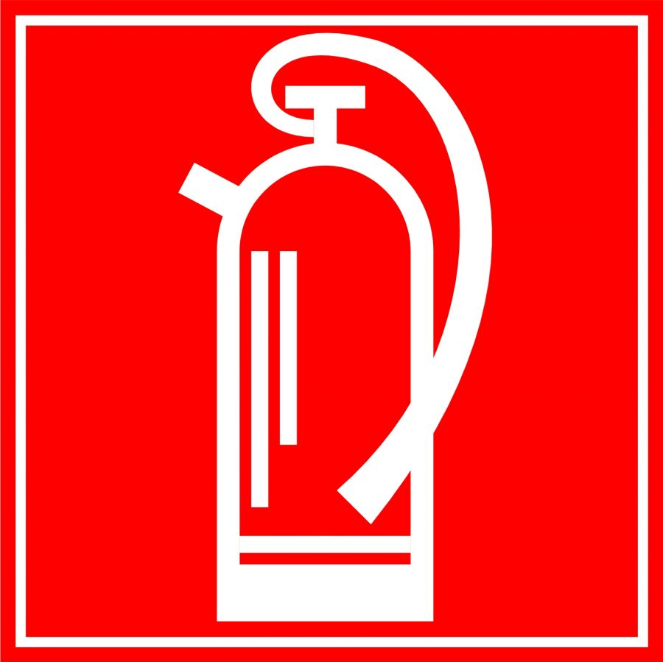
immediately be disconnected from the circuit.
Depending on the nature of the accident, appropriate rescue teams
should be alerted and evacuees at risk
The general rules for behavior in case of danger apply

Accidents and First Aid
 | In case of ingestion of toxic plant samples or skin / eye contact, a doctor should always be consulted  After skin contact with bacterial suspension: wash immediately with soap and plenty of water, remove contaminated clothing.  After ingestion of bacterial suspension: NEVER infuse water to an unconscious person. Rinse mouth with water, drink a maximum of 2 glasses of water; in case of diarrhea, nausea or  vomiting consult a doctor.  In case of cuts by pliers or razor blade: Stop bleeding, consult a doctor if necessary In the  event of injury, burns or frostbite from the freezer, alert first responder, ambulance or doctor if necessary. Inform supervisor (if necessary entry in the association book).

Proper disposal
The proper disposal of the cooled or frosted material depends on the properties of the material and must be adapted to it. Otherwise, the information in the operating instructions and in corresponding test reports for cold and frost resistance measurements apply..

Signature
Supervisor: Signature:

Town: Date:

