 |  |  | Operating instructions | 

Work equipment – Equipment – Apparatus - Device
Confocal Laser Scanning Microscope

Dangers for humans and the environment
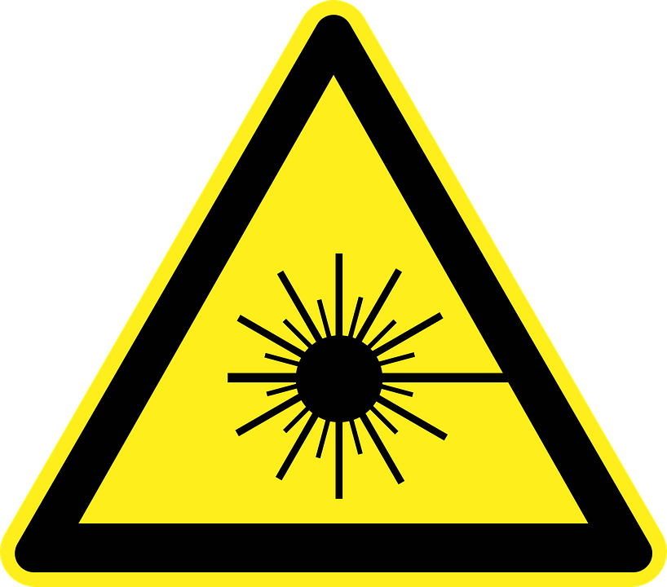 | - Danger due to laser light

Protective measures and rules of conduct
- Commissioning via the central connector strip (left of the microscope)
- Turn on the computer and microscope
- Manually switch on He Ne or argon laser
- In normal operation, the laser beam is enclosed by a housing
- Coupled directly into the microscope and can not reach the eye
- Switch off the laser by means of a key; then turned on for about 5 minutes
- Leave until the fan turns off. Then switch off completely (, 0 ')
- Switch off microscope and computer
- Then switch the central power strip to '0'.

Faults and dangers
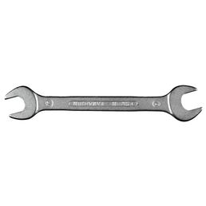 |  | - The housing of the laser must not be removed

Accidents and First Aid
 |  | - Rinse open wound, allow to bleed if possible and immediately with  - Spray the disinfectant, if necessary, add the disinfectant and refill  - Allow to act for at least 30 minutes.  - If necessary, alert first responder, ambulance or doctor. Supervisor  - inform (if necessary entry in the book of associations

Tests – Maintenance - Disposal
- Maintenance and repair work may only be carried out with the written permission of
Laboratory manager.
- Allow to act for at least 30 minutes.
- If necessary, alert first responder, ambulance or doctor.
- Supervisor inform (if necessary entry in the book of associations) ..

Signatures
Supervisor: Signature:

Town: Date:

