 |  |  | Operating instructions | 

Work - Equipment - Apparatus -Device
Chloroform

Dangers for humans and the environment
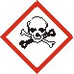  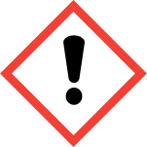  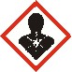 | Colorless liquid.  Signal word: Attention  H351 Suspected of causing cancer.  H373 May cause damage to organs through prolonged or repeated exposure.  H302 Harmful if swallowed.  H315 Causes skin irritation  P280 Wear protective gloves / protective clothing / eye protection / face protection.  P260 Do not breathe mist / vapors / spray.  P302 + P352 IF ON SKIN: Wash with plenty of soap and water.  P308 + P313 IF exposed or concerned: Get medical advice / attention  Violent to explosive reactions with:  Alkali metals, alcohols, aluminum, amines, ammonia, alkaline earth metals, fluorine, alkalis, organic nitro compounds, methanol, sodium hydroxide, peroxi compounds, oxygen,  Violent reactions possible with:  Metals, bis- (dimethylamino) -dimethyltin  May cause birth defects. Harmful by inhalation and if swallowed. Irritates the skin. Irreversible damage possible. Danger of serious damage to health by prolonged exposure. May cause cancer. Contact with eyes, skin and mucous membranes causes irritation. Ingestion causes nausea and vomiting. Inhalation of vapors causes coughing and dyspnoea. After absorption of the substance seizures, agitation and anesthesia occur. It can cause liver and kidney damage. Highly water polluting substance (WGK 3). Harmful to aquatic organisms.  Do not allow to enter sewage, bodies of water or soil

Protective measures and rules of conduct
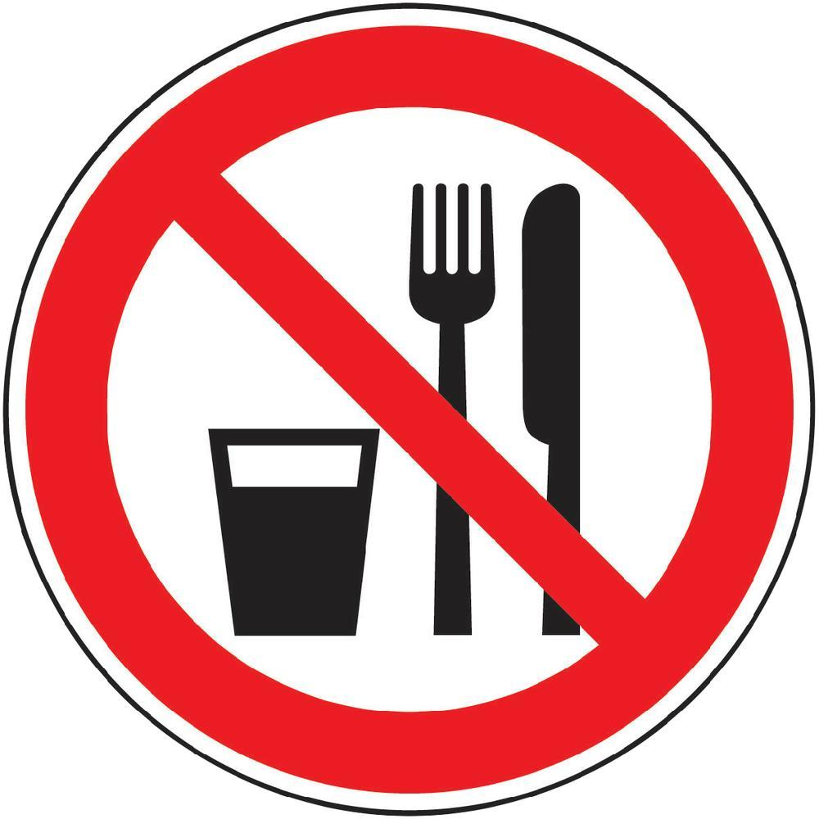 |  | General information  Keep away from food, drink and animal feed.  Take off dirty, soaked clothes immediately.  Wash hands before breaks and at the end of work.  Avoid contact with eyes and skin.  Do not inhale gases / vapors / aerosols  Personal protective measures |  |  |  | - pE
Glove material: fluororubber (Viton) ≥ 0.7 mm. Neoprene gloves only for short term protection.
Eye protection: Tightly sealed goggles

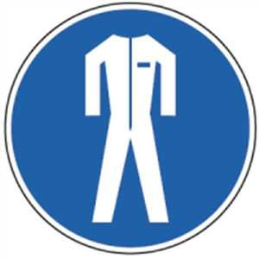
Body protection: protective clothing

Respiratory mask: Half mask filter class ABEK (as included in emergency kit MUI)
Working in the fume hood. Do not inhale or bring to the skin.



Use and storage:
Keep container tightly closed. Ensure good ventilation / exhaustion at the workplace. In front
Protect the light. Recommended storage temperature: 15 - 25 ° C

Disruptions and Dangers
 |  | Chloroform does not burn itself, fire extinguishing measures to suit the environment.  Respiratory protection: Respiratory mask: Half mask filter class ABEK (as included in emergency kit MUI) CO2, extinguishing powder or water spray. Bigger fire with water spray  or alcohol-resistant foam. There are no extinguishing agent restrictions for this substance.  Ambient fire can produce dangerous fumes. In case of fire, the following can be released:  Hydrogen chloride (HCl), phosgene, carbon monoxide and carbon dioxide.  Do not inhale vapors. Avoid skin and eye contact. Ensure adequate ventilation. Wear personal protective equipment. Clear danger zone, proceed according to emergency plan, consult expert.  Do not empty into drains / groundwater / soil.  Absorb with liquid-binding material. Have the collected material disposed of by the University's Chemical Disposal Department.

Accidents and First Aid
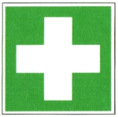 |  | General information:  First Aider: Pay attention to self-protection! Product contaminated garments  remove.  After inhalation:  Feed in fresh air. In case of dyspnea, allow oxygen to be inhaled, if necessary give a breath. Call a doctor immediately.  After skin contact:  Thoroughly wash with plenty of soap and water. Preventive skin protection through skin protection ointment.  After eye contact:  When eyes are open, rinse eyes with running water for 15 minutes under running water and consult a doctor.  After swallowing:  Rinse mouth and drink (let) a glass of water. Do not induce vomiting. Caution! See a doctor immediately  Most important symptoms and effects, both acute and delayed: dyspnoea and impaired locomotor coordination. Coughing, excitement, nausea, vomiting, headache. Repeated exposure may cause skin dryness or cracking.

Tests – Maintenance - Disposal
Dispose of as special waste (halogen-containing solvents)

Signatures
Supervisor: Signature:

Town: Date:

