 |  |  | Operating instructions | 

Work equipment – Equipment – Apparatus - Device

Bunsen Burner / compressed gas cartridges

Dangers for humans and the environment
  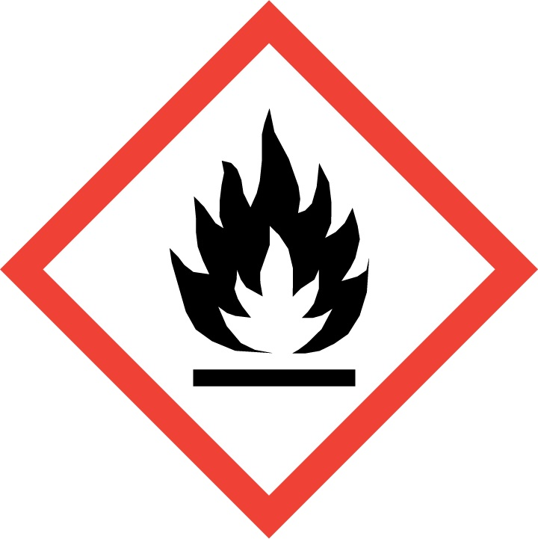 | - The compressed gas cans contain propane / butane LPG. (It is easier to recognize by adding odors)  - Refer to Hazardous Substances Instruction No. 61  - The gas is highly flammable  - Air can cause explosive mixtures. (Ignition range 1.5 - 8.5%)  - Risk of uncontrolled gas leakage / fire.  - Danger of bursting of containers in case of impermissible heating

Protective measures and rules of conduct
 |  | - During use, the enclosed instructions for use must be observed.  - The Bunsen burner Labogaz 470 may only be operated with the butane gas can CV 470 and CV 270!  - When installing or removing the burner, always ensure that there is good ventilation or work in the fume cupboard. Never install the burner near sources of ignition (hot surfaces, flames, sparks, etc.) on the compressed gas package.  - Keep a safe distance to flammable materials.  - Do not shake pressurized gas pack before lighting; after the lighting, let it rest for a few minutes. Avoid excessive movement during operation. Installation on a horizontal surface.  - Do not heat compressed gas container above 50 ° C. (Sun, other burners, heaters etc.)  - Store in well-ventilated areas.  - Do not forcibly open or burn compressed gas packing |  |  |  | - pE

Faults and dangers
 |  | - If liquid gas with long flames escapes: Put the appliance straight, close the gas valve. Wait a short time before reusing it.  - In the event of unintentional gas leakage: allow gas to be blown off in the open air or in the fume cupboard.  If gas has ignited in an uncontrolled manner: Close the valve with a damp cloth while protecting it, extinguish the flame by completely covering it with a damp cloth or by using a fire extinguisher.  - Do not handle needles, wires etc. with clogged nozzles. Clogged nozzles must be completely replaced.  - Do not carry out any repairs on the device yourself or make any changes.

Accidents and First Aid
 |  | - Close valve, secure accident site.  - Call first responder, if necessary doctor / emergency doctor.  - Inform incoming support personnel of any dangers.  - Provide information about the properties of the substances used for the doctor and assistant.  - Inform and consult the supervisor / representative depending on the severity of the  - accident.

Tests – Maintenance - Disposal
- Only throw away completely empty containers! (No liquid - liquid noise when shaking - more in the container, residual pressure blown off, after removing the burner, container for a while, until everything is outgassed, leave in the hood)

Signatures
Supervisor: Signature:

Town: Date:

