 |  |  | Operating instructions | 

Work equipment – Equipment – Apparatus - Device
Band saw

Dangers for humans and the environment
 | - Tilting workpieces can tear the band saw blade and cause serious injury.  - Contact with the band saw blade causes cuts..  - In case of strong noise (from 80 dB (A)) there is a risk of hearing damage.  - The running band saw blade can grasp and pull in the work clothes.  - Chips and sharp-edged components may cause cuts.  - Danger of accident due to damaged band saw blades (for example blunt, torn).  - There is a risk of skin diseases when working with cooling lubricants.

Protective measures and rules of conduct
       |  | - The operating instructions of the manufacturer must be observed!  - Avoid tilting the workpiece when the workpiece is fed to the band saw blade.  - Dress band saw blade to the part required for cutting.  - Contact with the band saw blade must be avoided.  - Use personal protective equipment (including skin protection).  - Wear tight-fitting work clothes.  - Switch off the machine even during short interruptions and cover the saw blade behind.  - Do not remove splinters, chips and waste by hand, but with suitable tools.  - Do not use damaged band saw blades.  - It is forbidden to wear protective gloves (danger of getting into the rotating blade).  - To wear ear protection.  - If there is a risk of eye injuries, the goggles must be worn.  - Switch off the machine even during short interruptions and cover the saw blade behind. |  |  |  | - pE

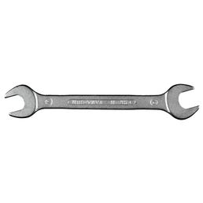
Faults and dangers
 |  | • If work equipment fails, discontinue work and inform the responsible teacher.

Accidents and First Aid
 |  | - Attract first responders  - Emergency call: 144  - Report accident to responsible

Tests – Maintenance - Disposal
- Maintenance (maintenance, repair) should only be carried out by qualified and authorized persons.
- After maintenance, the protective equipment must be checked.
- Observe the operating instructions of the manufacturer during maintenance.
- Regular checks (e.g., electrical, mechanical) by qualified persons.

Signatures
Supervisor: Signature:

Town: Date:

