 |  |  | Operating instructions | 

Work equipment – Equipment – Apparatus - Device
Autoclave

Dangers for humans and the environment
     | • Risk of burning / scalding on steam, hot liquids or objects.  • Danger of bumping when opening and moving vessels filled with hot liquid.  • Danger from bursting vessels.  • Risk of overpressure (possible explosion).  • Danger of infection from items to be sterilized or unsterilized material.  • Damage to health due to hazardous substances contained in the sterilized  material (see corresponding safety data sheets.)  • The general rules for handling electrical equipment apply (see relevant.  operating instructions).

Protective measures and rules of conduct
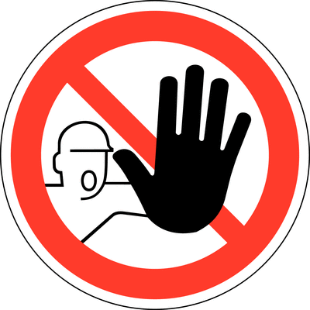  Use  - Check sealing surfaces and locking mechanism for damage and soiling before use.  - Contaminants in the water tank and on the heating coil (lifting the perforated plate) must be removed  Before autoclaving  - Both drain hoses are positioned and fixed in the sink above the drains  - Autoclave to below the perforated plate with A. dest. or A. deion. fill (no tap water!)  - Position the temperature sensor correctly. In the case of liquids, immerse the sensor in a vessel  With the same volume of water as in the autoclave material.  - For solids, fix the probe to the underside of the lid.  - Autoclave only glass and instruments that are suitable for steam sterilization>134°Cby the manufacture For solids, fix the probe to the underside of the lid.  - Autoclave only glass and instruments that are suitable for steam sterilization> 134 ° C by the manufacturer  - Do not autoclave flammable liquids and heat-sensitive materials |  | General information  Autoclaves may only be used by instructed persons, who have reached the age of 18, who possess the required expertise in terms of facilities and procedures and who expect them to perform their duties reliably  Personal protective measures  Wear personal protective equipment (PPE) when handling sterilized items.  When opening or unloading, wear a protective shield and heat-resistant protective gloves (eg leather).  - Fill vessels only up to 75% of the final volume  - Loosely tighten the bottle cap, NEVER close it tightly  - Be careful with viscous liquids, such as B. Agar solutions, these can be cooled to at least 60 ° C.  - Check pressure-free autoclave before opening the shutter mechanism (gauge).  - Even at atmosphere pressure, the temperature of the autoclave can still be 100 ° C or higher  - The autoclave can also be opened when the liquids are still boiling  - Open carefully. Temperature sensor may be outside the liquid or the sensor vessel may be broken  - Never force open the autoclave.  - Wear appropriate PPE when opening or unloading  - After operation and if there is a risk of autoclaving, switch off the autoclave using the main  switch (on the back of the device).  - In the event of glass breakage, the sterilization chamber must be thoroughly and immediately  - Do not autoclave flammable liquids and heat-sensitive materials. |  |  |  | E

Faults and dangers
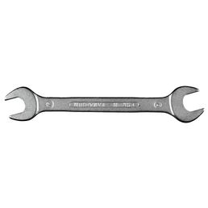 |  | - In the case of technical defects and malfunctions, the work must be interrupted immediately.  - If there is a danger of the autoclave, switch off the autoclave with the main switch (on the back of the device) and disconnect it from the power supply  - Inform the laboratory supervisor or other responsible person..  - Pay attention to self-protection  - Prevent restarting  - Service work and repairs may only be carried out by service technicians authorized by the manufacturer.  - Inform superiors and repairs must be carried out exclusively by a specialist workshop..  - Notify the laboratory supervisor or other responsible person.  - In case of fire, fight the fire with a foam or CO2 extinguisher.  - Consider self-protection.

Accidents and First Aid
 |  | First Aider: Pay attention to self-protection!  - Rescue injured persons from the danger zone and provide first aid  - Shower burned areas of the body with lukewarm tap water for 10-15 minutes. Do not join wounds or use bandages with metal coating.  - Alert first responders, ambulance or doctor if necessary

Tests – Maintenance - Disposal
- When performing maintenance, disconnect the device from the power source.
- The autoclave does not have to be checked regularly by the TÜV, as the chamber volume is low

Signatures
Supervisor: Signature:

Town: Date:

