 |  |  | Operating instructions | 

Work - Equipment - Apparatus -Device
Acrylamid

Dangers for humans and the environment
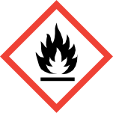  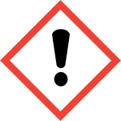  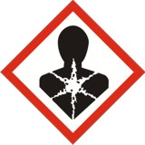 | Signal word Danger!  Dangerous reactions with alkalis, acids, oxidizing agents. Upon heating to the melting point, vigorous exothermic polymerization may occur.  May cause cancer!  Toxic by inhalation, Harmful if swallowed, in contact with skin.  Vapors and solutions irritate eyes and skin.  Acrylamide is a strong neurotoxin.  Can cause cancer. (H350)  May cause genetic defects. (H340)  Suspected of damaging fertility. (H361f)  Toxic if swallowed. (H301)  Harmful if inhaled. (H332)  Harmful in contact with skin. (H312)  Causes damage to organs through prolonged or repeated exposure. (H372)  Causes serious eye irritation. (H319)  Causes skin irritation. (H315)  May cause allergic skin reactions. (H317)

Protective measures and rules of conduct
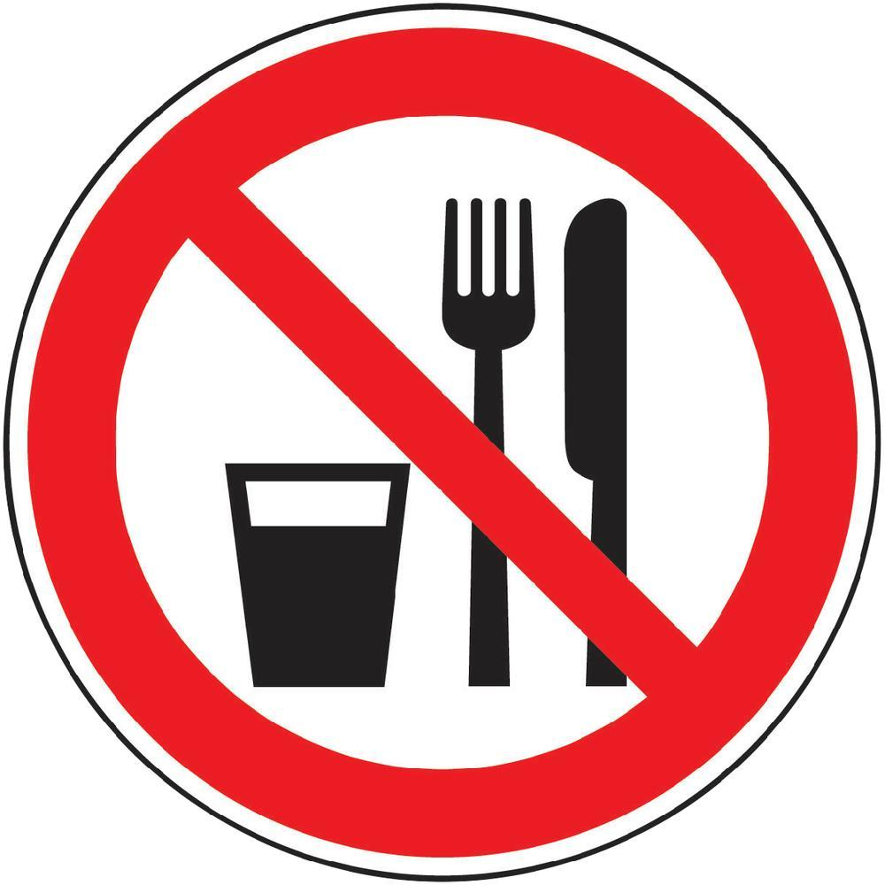  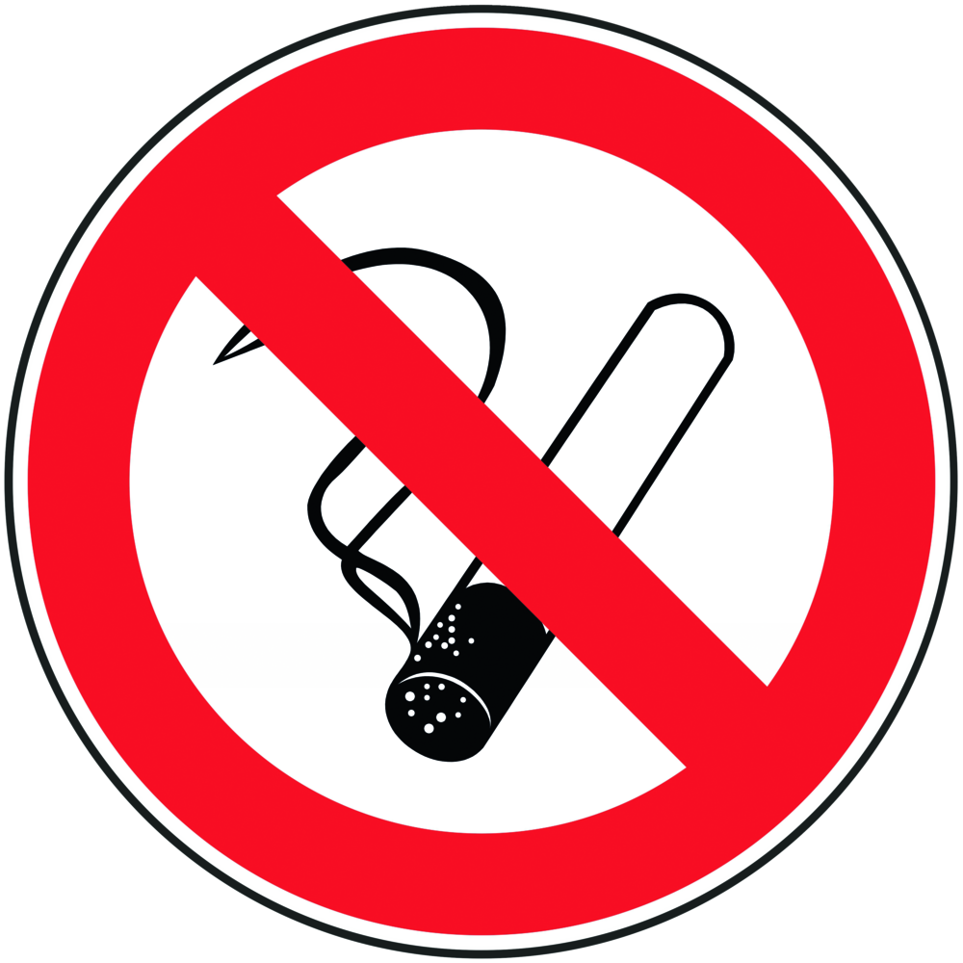 |  | General information  Read exactly the safety data sheet before starting work!  - Only work in the trigger and keep the sash closed. Use closed equipment as much as possible. Fully polymerized acrylamide also contains dissolved monomer residues in aqueous solution. For gel electrophoresis, use ready-made gels whenever possible. If gels are used, work in the fume hood. Do not leave vessels open! When draining, transferring or mixing avoid dust formation. Keep reactive substances away or only add them in a controlled manner. Spatial separation and identification of workplaces - stay only if necessary. Use tools that prevent or reduce skin contact.  - Avoid breathing dust. (P261)  - Avoid dust deposition and whirling up! Keep supplies to a minimum in the laboratory, keep them protected against flame and heat. Keep away from sources of ignition (eg not smoking, no open flames, earth)! Because explosive dust only works in the fume hood with explosion-  - proof fan. Clean or vacuum clean (only with explosion-proof industrial vacuum cleaners).  - Avoid heating  - Not eating, drinking or smoking. Avoid inhalation of dusts!  - Avoid contact with eyes, skin and clothing! After work and before each break thoroughly clean hands and other soiled parts of the body. Use skin care products!  - Immediately remove product residues from the skin, clean the skin gently and dry thoroughly. Wash off, do not allow to dry. Do not wear an arm or hand jewelry. Keep street clothes separate from work clothes! Change soiled work clothes immediately.  - Use separate cleaning rags and cleaning cloths for skin and machinery or equipment  - Observe employment restrictions!  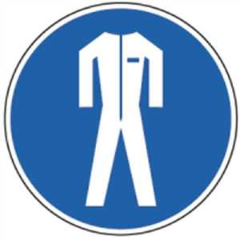  Personal protective measures  Use prescribed personal protective equipment. (P281)  Wear protective goggles and lab coat.  Eye protection: frame glasses with side protection.  Hand protection: natural rubber / natural latex (NR, 0.5 mm), polychloroprene (CR, 0.5 mm), nitrile rubber / nitrile latex (NBR, 0.4 mm), polyvinyl chloride (PVC, 0.5 mm), butyl rubber (butyl; 0.5 mm), fluororubber (FKM, 0.7 mm) (penetration time> 8 hours, maximum wearing time 8 hours).  Respiratory mask: Half mask filter class ABEK (as included in emergency kit MUI)  When wearing protective gloves, cotton underwear gloves are recommended!  For long-term use of protective gloves: use special skin protection before work. |  |  |  | - pE
Research groups - internal handling

- For safety reasons, only finished gels (solutions) may be used in the research group. Acrylamide in powder form is not available and must not be used or processed.
- Do not use glass containers (i.e. beakers) during handling and disposal of acrylamide. Instead, plastic centrifuge tubes (Falcons) are used, which are then immediately closed and disposed of as hazardous waste. In this way, a risk of contaminated glass jars is avoided and no cleaning is required.

Use and storage

Keep bottles tightly closed, cool and protected from light.

Disruptions and Dangers
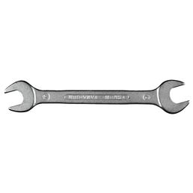 |  | Carefully collect spilled substance and dispose of it as hazardous waste.  Spilled solution with binder e.g. Pick up Rench-Rapid and dispose of it as special waste.  Clear and close the danger area, inform supervisors. Always wear protective goggles, gloves and larger quantities of respiratory protection when removing spilled / spilled product. Respiratory mask: Half mask filter class ABEK (as included in emergency kit MUI). Pick up and dispose of dust prevention!  Product is flammable, but only a short burning and rapid extinguishing itself.  Genesis: Use portable fire extinguisher. Not to be used: full jet water! The use of carbon dioxide as an extinguishing agent for solids causes a risk of re-ignition. In case of fire dangerous vapors (for example carbon monoxide, nitrogen oxides) are generated!  Extinguishing Media: Water, foam. No carbon dioxide!

Accidents and First Aid
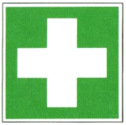 |  | After skin contact: Wash thoroughly with plenty of soap and water.  After eye contact: Rinse with plenty of water with the eyelid wide open for at least 15 minutes. Ophthalmologist!  After inhalation: Supply fresh air, if necessary, give breath.  Ingestion: Drink plenty of water. Induce vomiting. Ambulance!  After clothing contact: Remove contaminated clothing, including underwear and shoes immediately. Thoroughly wash with soap and water. Helpers pay attention to self-protection.  First responders: list next to each phone

Tests - Maintenance - Disposal
Plastic centrifuge tubes (Falcons) are used, which are then immediately closed and disposed of as special waste.

General:
Do not pour acrylamide solutions into the spout, but bring to a concentration of 8-10% with water and in a neutral to slightly alkaline medium (pH 7-8) in portions (maximum 50 ml in a 200 ml beaker) in a fume hood with addition of 1 .mu.l of 40% ammonium persulfate / ml and 0.5 ul tetramethylethylenediamine / ml polymerize overnight. Collect and waste for disposal and return it to the waste collection point. Do not pour into a spout or dustbin! Also dispose of empty containers as special waste, do not put in garbage cans.

Signatures
Supervisor: Signature:

Town: Date:

