 |  |  | Operating instructions | 

Work - Equipment - Apparatus -Device
Acids and Bases

Dangers for humans and the environment
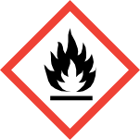  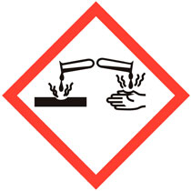  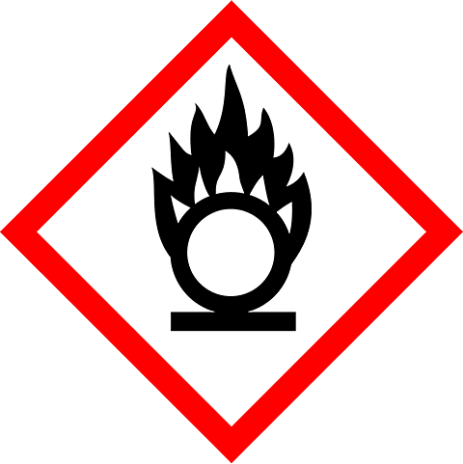  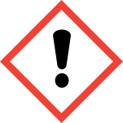  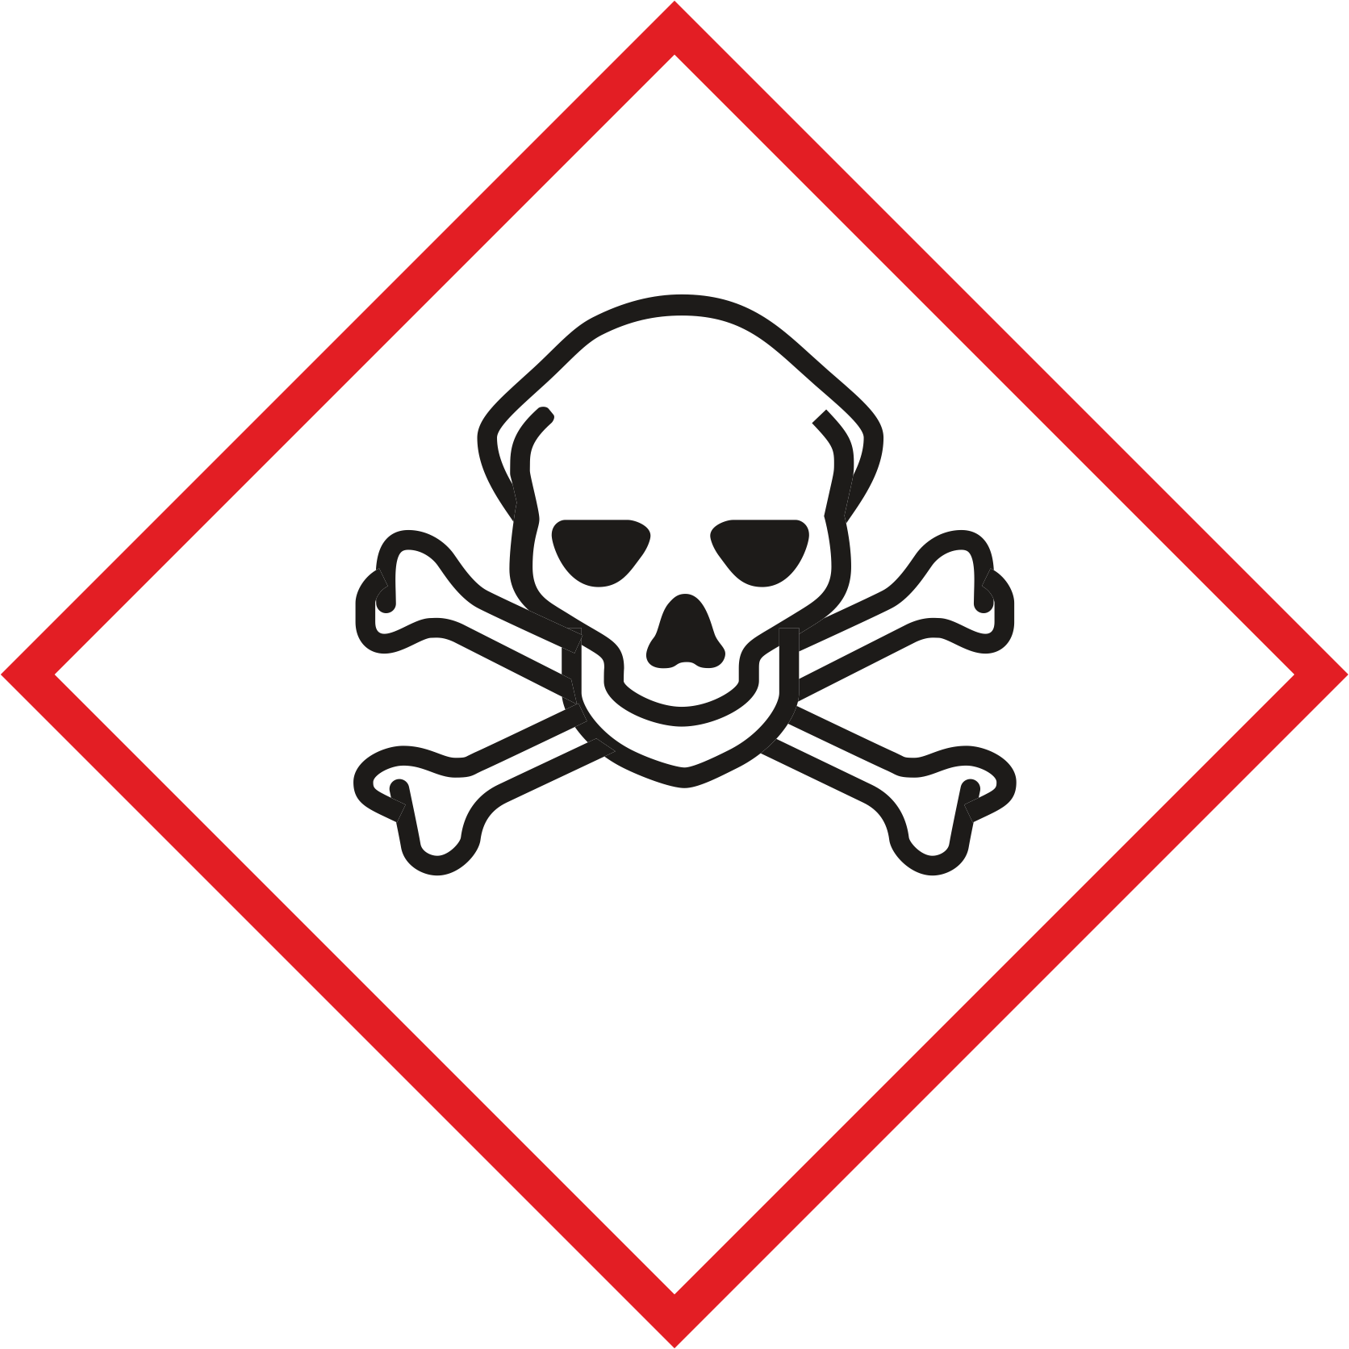  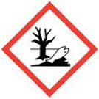 |  | Solid or liquid, water-soluble or miscible pure substances. When diluted with water, they sometimes develop strong heat, usually strong caustic effects.  Most hazardous to water.  Form: solid and liquid substances  Hazard class: Etching / irritation of the skin and mucous membranes  Color: varying Almost all acids and bases are corrosive. The skin, mucous membranes or the retina can be irreversibly damaged.  May cause severe skin burns and / or serious eye injury (Cat. 1)  May cause an allergic skin reaction and / or severe eye irritation (Cat. 2)  Acids often react with metals under hydrogen evolution (danger of explosion!)  Often classified as hazardous to the aquatic environment.  Acids and alkalis are often very toxic!  Read the safety data sheets carefully before starting work!

Protective measures and rules of conduct
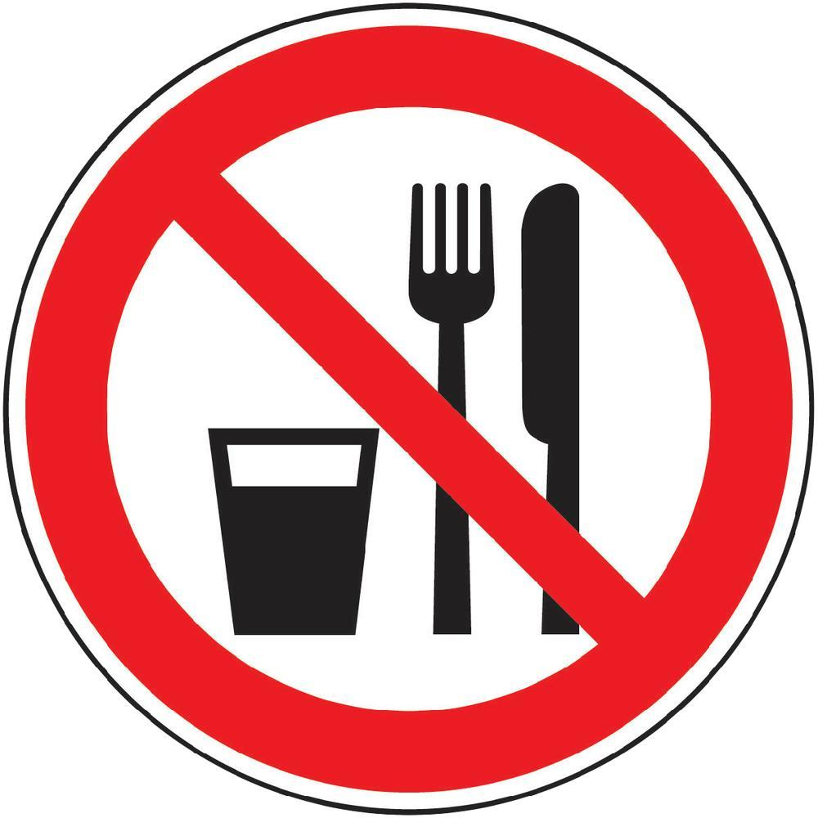  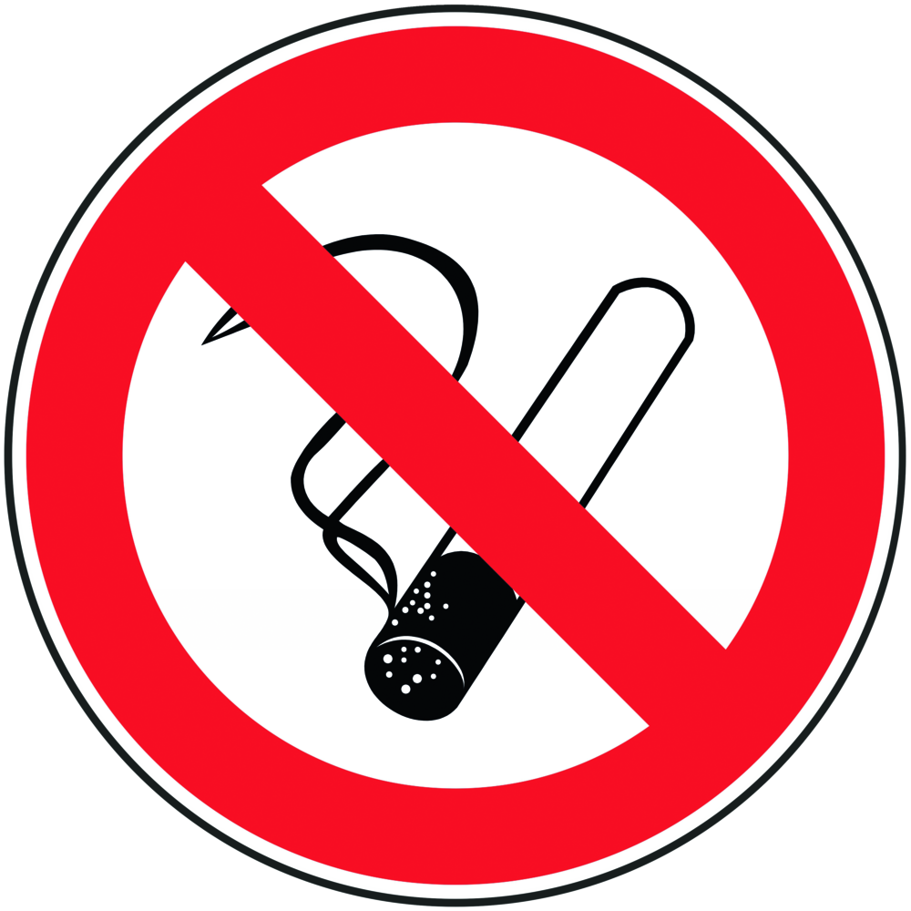 | General information  Basically to dilute acids in water.  Avoid contact with skin, mucous membranes and eyes.  Avoid formation of vapors and mists.  Ventilate rooms well.  Do not smoke, eat or drink! |  |  |  |  | - pE
Personal protective measure
Wear suitable gloves and goggles or face shield.

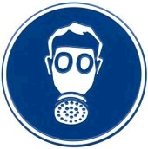

Use and storage
Use exhaust at work.
Do not use metal containers.
Keep container closed. Store only via drip tray.
Change soiled clothing immediately.

Transport
When storing, transferring and processing liquid substances, use collection tray.

Disruptions and Dangers
 | In case of fire:  Extinguishing measures to suit the environment.  Use self-contained breathing apparatus.  Prevent the ingress of extinguishing agents into sewage, soil and water.  After spilling / leaking:  Exit the substance. First dilute, then neutralize.  Spread acid binder.  Eliminate slipping hazard.  Do not allow to enter drains / soil.

Accidents and First Aid
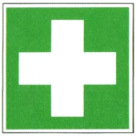 | After inhalation: Supply fresh air, if necessary, inhale.  After eye contact: Rinse thoroughly with water.  After skin contact: Wash thoroughly with soap and water.  Ingestion: Do not induce vomiting. Rinse mouth with plenty of water,  seek medical attention immediately.  After burns: cool wound, seek medical attention.

Tests - Maintenance - Disposal
Dispose of residues and waste as hazardous waste Do not dispose of waste in a dustbin or spout.

Signatures
Supervisor: Signature:

Town: Date:

