 | Operating instructions | 

Disposal
Acids and acid mixtures

Contaminated resources
Acids and acid mixtures
Acids (separate collection in their own containers) and acid mixtures (for example sulfuric acid, hydrochloric acid, nitric acid, phosphoric acid, hydrofluoric acid, acetic acid, mixtures of the abovementioned acids only after consultation - see below)
UN numbers: 1760, 1850, 1832, 1992, 2013, 279

Contaminated solids
Acids – collected in separate containers, mixtures of acids (e.g. sulphuric acid, hydrochloric acid, nitric acid, phosphoric acid, hydrofluoric acid, acetic acid, mixture of above – named acids only after talking to…-see below) |  |  | - pE

Clippings
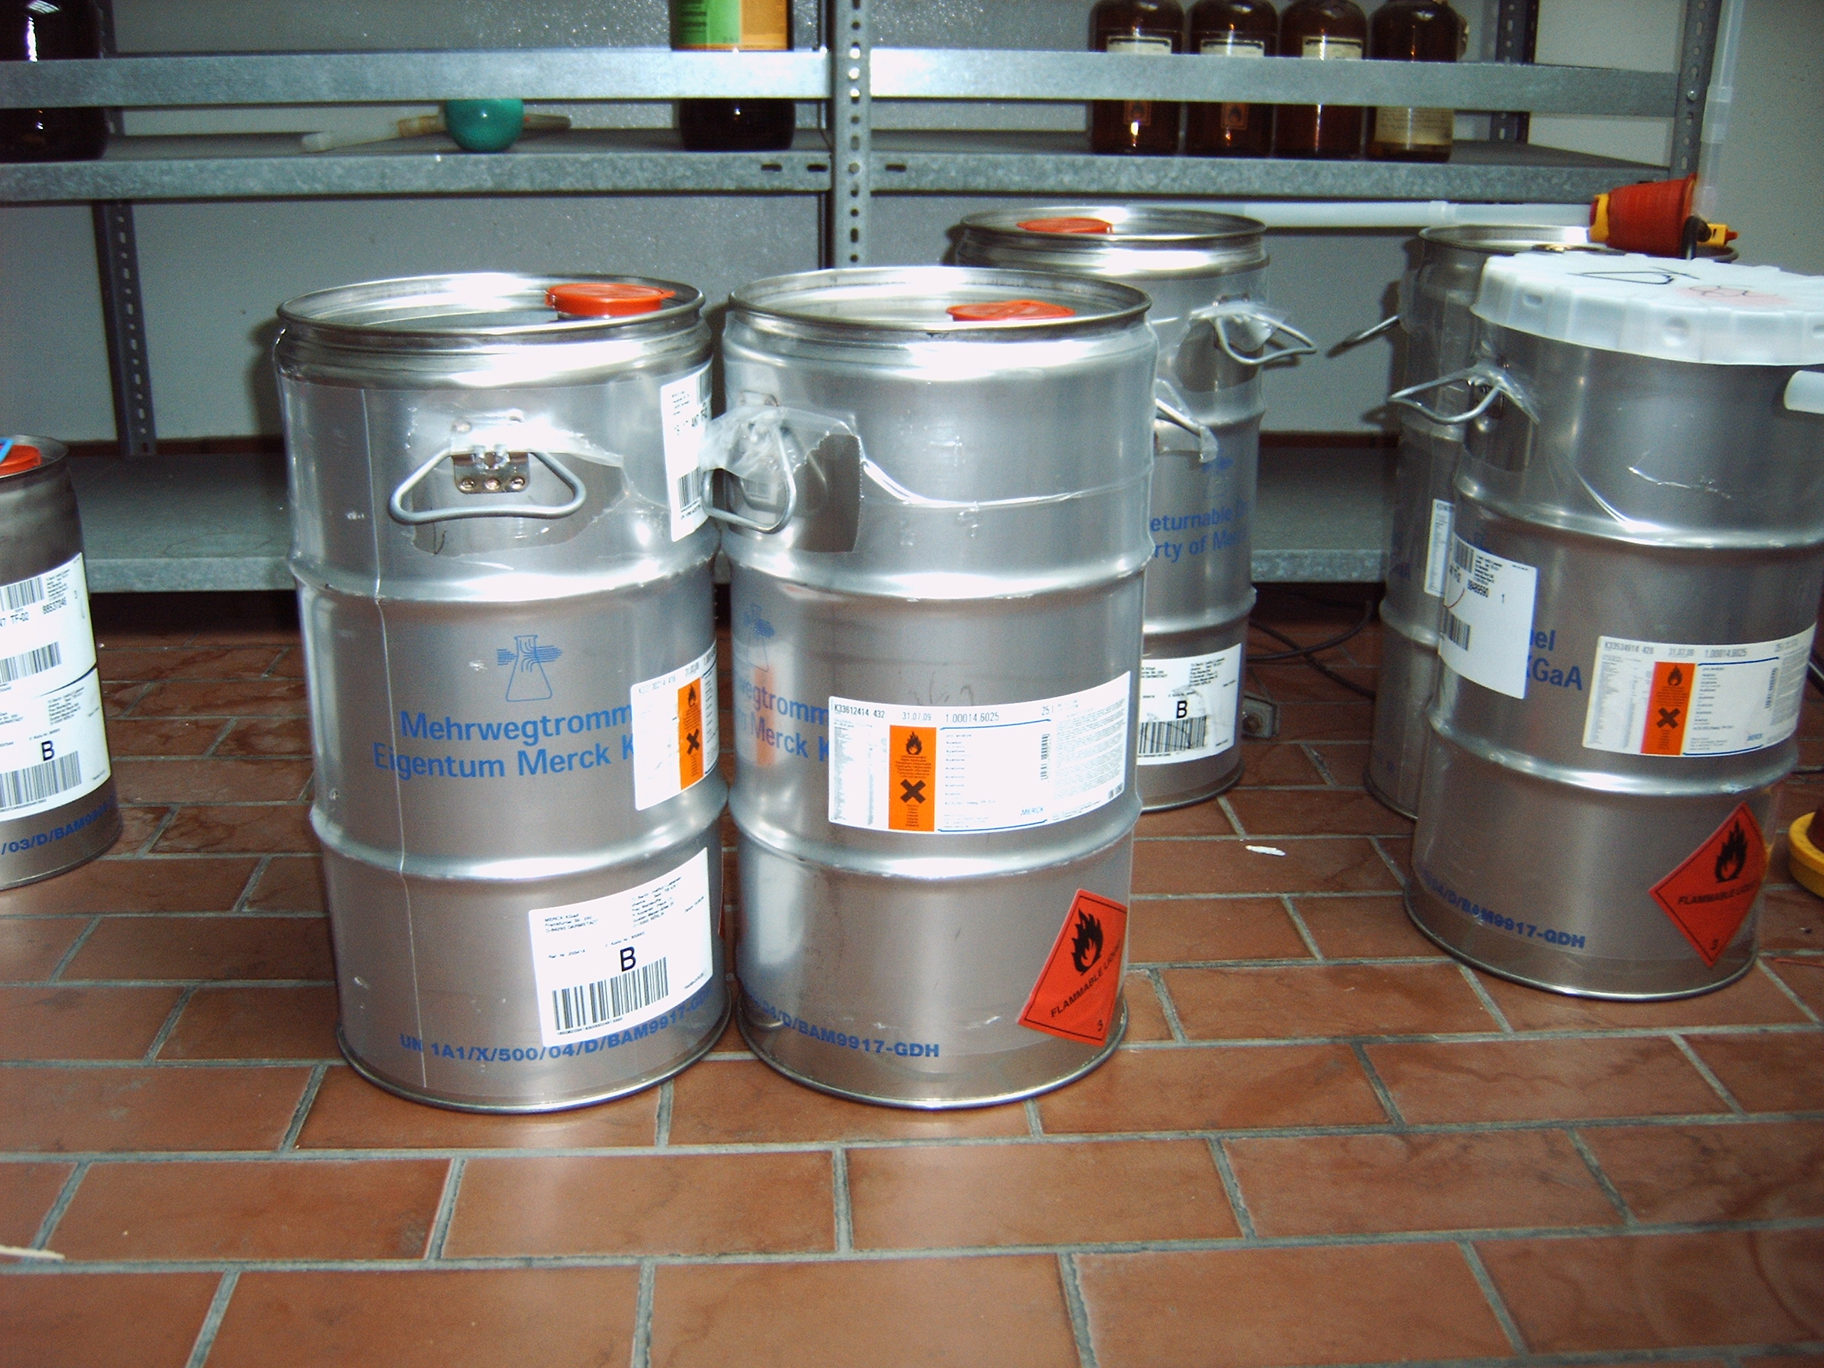
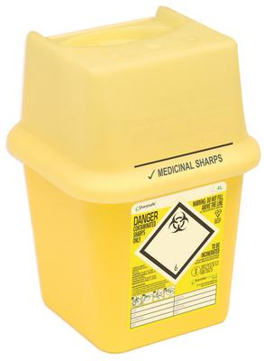
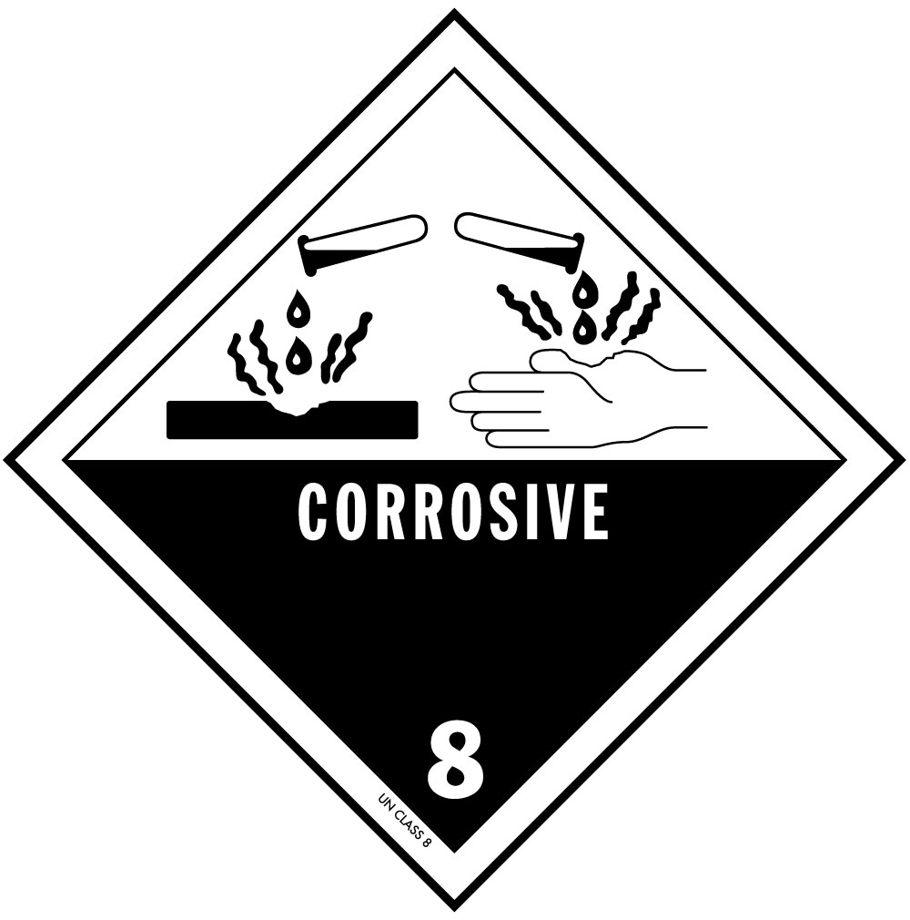
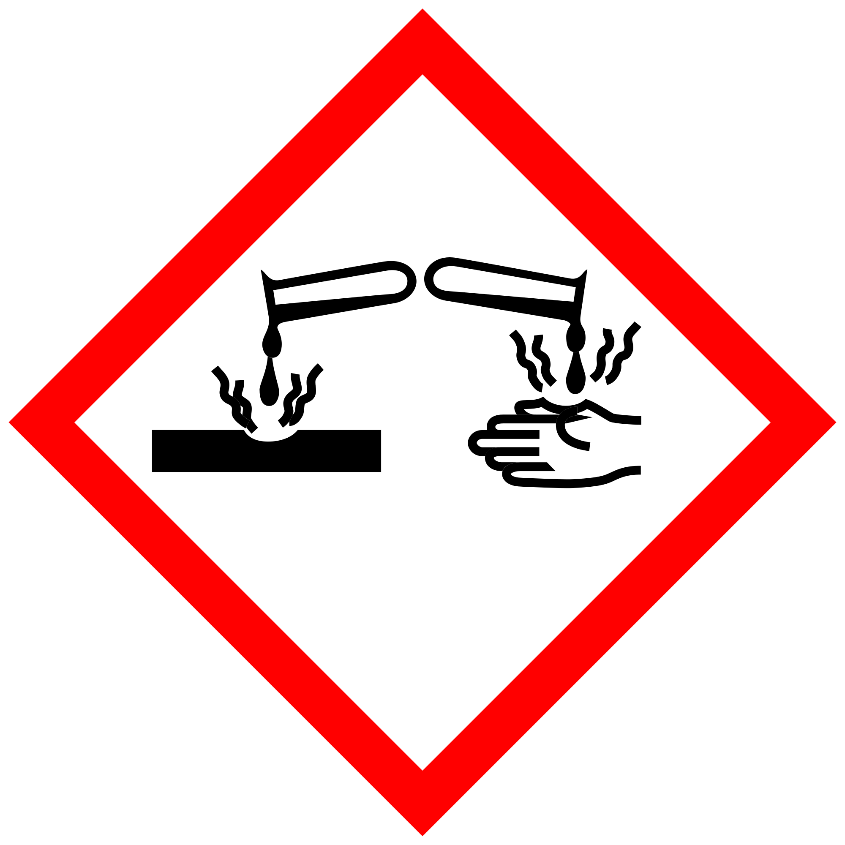


The following substances may not be collected together with this type of waste:
organic solvents
Concentrated perchloric acid, as it is disposed of as an inorganic chemical (AVV No. 16 05 07)
Fuming sulfuric acid
Important: Collection of acid mixtures only after consultation with the supervisor
NOT to be collected together with this waste type:
- Organic solvents
- Fumic sulphuric acid
- Perchloric acid (has to be disposed as “inorganic chemicals”, AVV-Nr. 16 05 07)
- Important: collection of mixtures of acids only after talking to your boss

Signatures
Supervisor: Signature:

Town: Date:

