 |  |  | Operating instructions | 

Work - Equipment - Apparatus -Device
Acetonitril

Dangers for humans and the environment
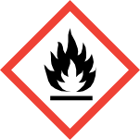  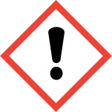 |  | Signal word: Attention!  Hazard statements (H-phrases)  H225 Highly flammable liquid and vapor.  H302 + H312 + H332 Harmful if swallowed, in contact with skin or if inhaled  H319 Causes serious eye irritation.  Safety instructions (P-phrases)  P210 Keep away from heat / sparks / open flames / hot surfaces. Do not smoke.  P280 Wear protective gloves / protective clothing.  P305 + P351 + P338 IF IN EYES: Rinse cautiously with water for several minutes. Remove contact lenses, if possible. Continue rinsing.

Protective measures and rules of conduct
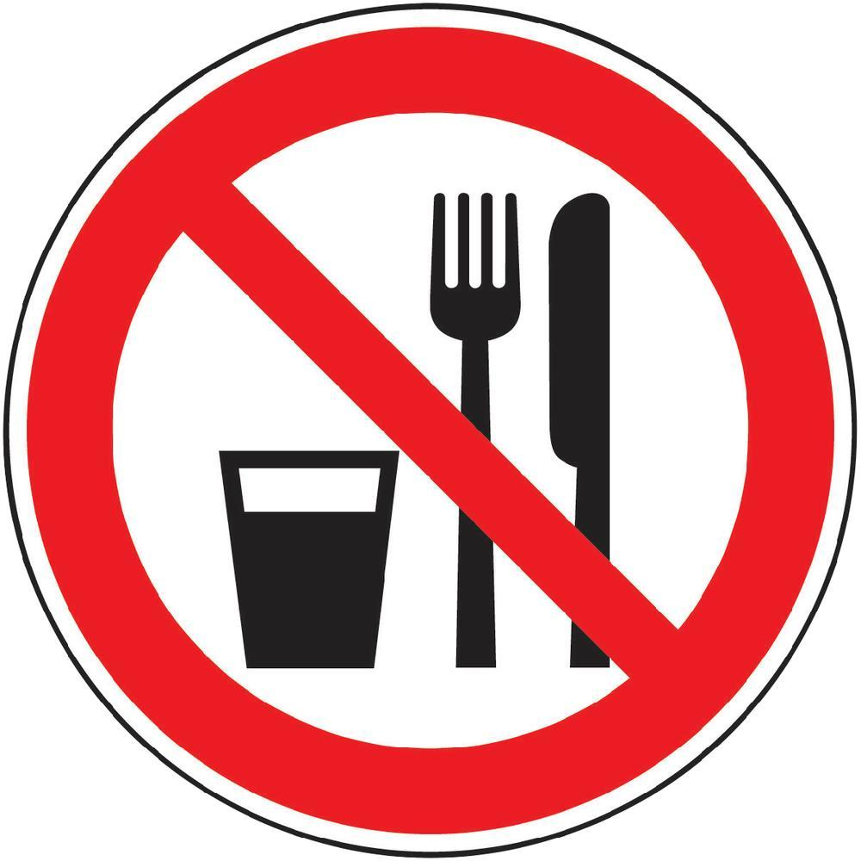    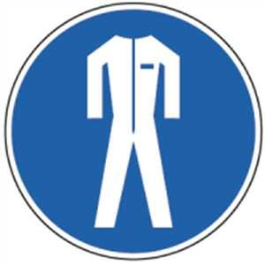  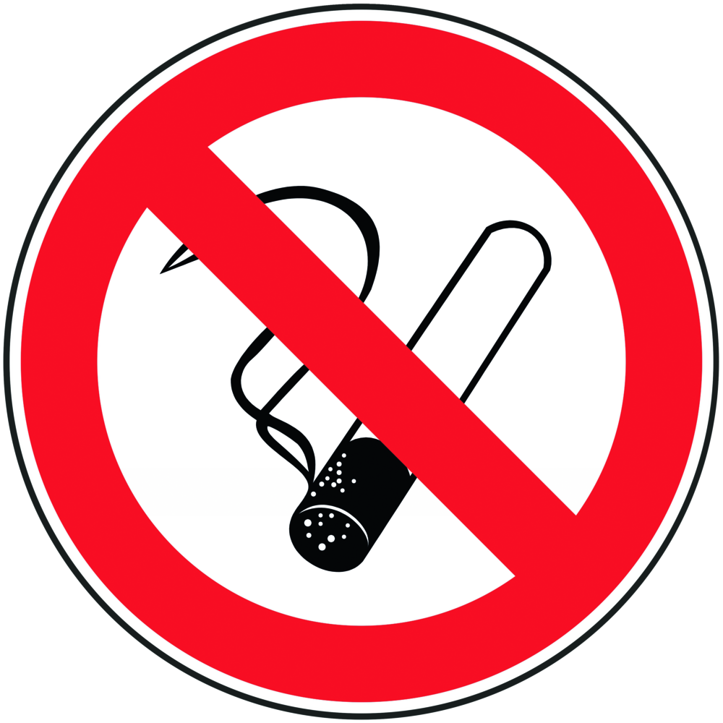 | General information  Precautions for safe handling:  Avoid contact with eyes and skin. Avoid inhalation of vapors or mist. Keep away from sources of ignition - No smoking. Take measures against electrostatic charging.  • Eating, drinking or smoking is prohibited in all laboratory facilities!  • Avoid contact with eyes and skin.  • Avoid sparks and flames!  Incompatible materials:  Acids, bases, oxidizing agents, reducing agents, alkali metals  Dangerous reactions with oxidizing agents (including perchlorates, perchloric acid, nitric acid, oleum), acids (including concentrated sulfuric acid), cyanopropyl nitrate.  Conditions to avoid:  Heat, flames and sparks. Extreme temperatures and direct sunlight.  Vapors are heavier than air and spread over the ground.  Personal protective measures  Eye / face protection:  Face shield and goggles.  Skin protection:  Working with gloves.  For hygiene reasons wear cotton gloves under butyl rubber gloves.  Material: butyl rubber  Minimum layer thickness: 0.3 mm  Breakthrough time: 480 min  Respiratory protection: work under the hood!  Do not inhale substance. Avoid development of vapors / aerosols  Required if vapors / aerosols are generated.  Respiratory mask: Half mask filter class ABEK (as included in emergency kit MUI)  During laboratory work, always wear a laboratory coat. |  |  |  |  | - pE
Use and storage
Storage: tightly closed, cool, in a well-ventilated place away from sources of ignition, away from flammable substances. Take precautionary measures against electrostatic charging.

Transfer and transport
The transport of liquids in bottles (from about 200 ml) must be done with the aid of a carrying basket.
When refilling, pay attention to appropriate protective equipment! Work under the trigger!

Disruptions and Dangers
 | Use personal protective equipment. Do not inhale vapors / mist / gas. Provide adequate ventilation. Remove all sources of ignition. Bring people to safety. Beware of vapors that can build up and form explosive concentrations. Vapors can accumulate in deep areas.  When gases and vapors are released, leave the room immediately, doing so  Possibility to open windows. Re-entry only under respiratory protection.  In case of fire:  Suitable extinguishing agents  Use water spray, alcohol-resistant foam, dry chemical or carbon dioxide. In case of fire, wear self-contained breathing apparatus, if necessary.  If spilled:  Absorb liquid with universal chemical absorber and dispose of it for chemical disposal. Clean up with water.  Environmental protection measures  Prevent further leakage or spillage if safe to do so.  Do not empty into drains.

Accidents and First Aid
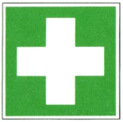 | General information  Consult a doctor. Show this safety data sheet to the attending physician.  After inhalation  If inhaled, remove affected person to fresh air. In respiratory arrest, artificial respiration. Consult a doctor.  After skin contact  Wash with soap and a lot of water. Consult a doctor.  After eye contact  Rise thoroughly with plenty of water for at least 15 minutes and consult a doctor.  After swallowing  DO NOT induce vomiting. Never give anything by mouth to an unconscious person. Rinse mouth with water. Consult a doctor.

Tests - Maintenance - Disposal
Dispose of as special waste (halogen-free solvent mixture). Do not dissolve in the wastewater
get there. Remains and waste in a suitable properly labeled container
Dispose of according to the Chemical Waste Management Guidelines.

Signatures
Supervisor: Signature:

Town: Date:

