 |  |  | Operating instructions | 

Work - Equipment - Apparatus -Device
Aceton

Dangers for humans and the environment
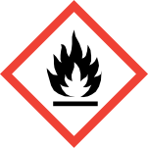  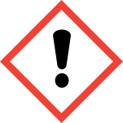 |  | Observe information of the safety data sheets!  Signal word Danger!  Classification according to Regulation (EC) No. 1272/2008  • Flammable liquids  • Eye irritation  • Specific target organ toxicity, single exposure, narcotic effect  Hazard statements (H-phrases)  • H225 Highly flammable liquid and vapor.  • H319 Causes serious eye irritation.  • H336 May cause drowsiness and dizziness.  • EUH066 Repeated exposure may cause skin dryness or cracking.  Safety instructions (P-phrases)  • P210 Keep away from heat / sparks / open flames / hot surfaces. Do not smoke.  • P280 Wear protective gloves / protective clothing / eye protection / face protection.  • P305 + P351 + P338 IF IN EYES: Rinse cautiously with water for several minutes. Remove  contact lenses, if possible. Continue rinsing.

Protective measures and rules of conduct
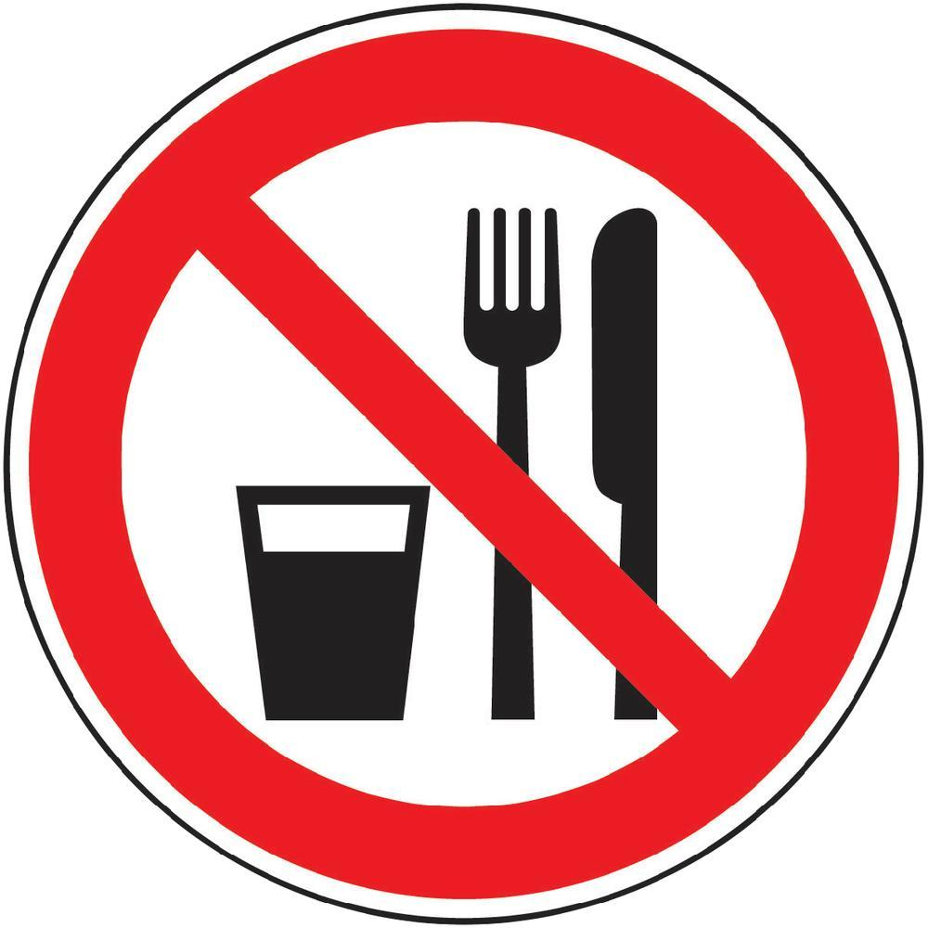  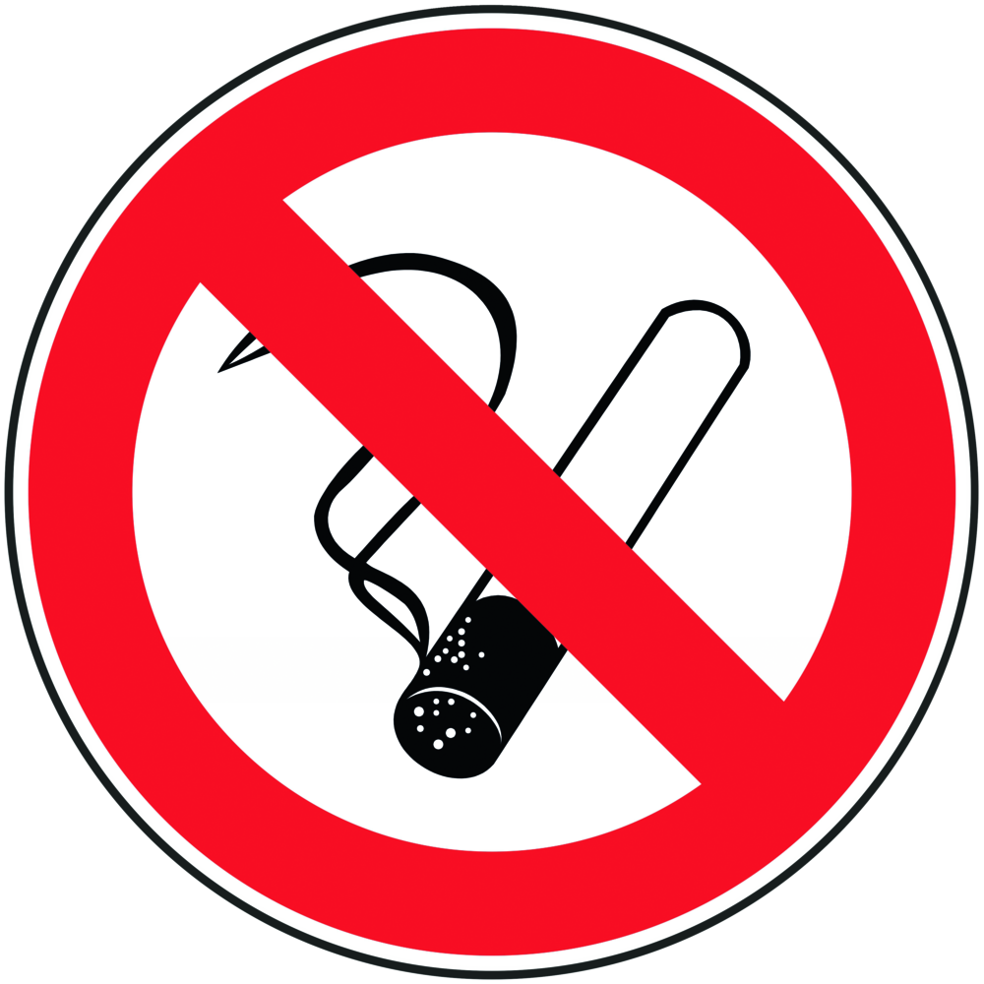  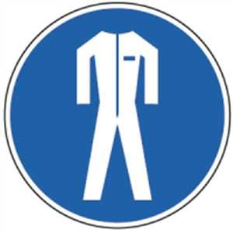   | General information  Eating, drinking or smoking is prohibited in all laboratory facilities!  Inhalation, avoid contact with eyes and skin.  Use trigger. In case of open handling adequate ventilation of the working area.  Keep away from sources of ignition.  Personal protective measures  Eye protection: frame glasses with side protection.  Skin protection: For short-term hand contact: nitrile rubber; Thickness 0.425mm;  Respiratory protection: Required if vapors and aerosols are generated.  Half mask filter class ABEK (as included in emergency kit MUI)  Breakthrough time: 10min  For more frequent hand contact: Butyl rubber, thickness 0.5mm  Body protection: Lab coat  Use and storage  Keep away from sources of ignition.  Take precautionary measures against electrostatic charging.  Do not inhale vapors / aerosols.  Work under the hood or ventilate well.  Storage:  Keep container tightly closed in a well-ventilated place.  Store away from sources of ignition and heat and store away from light.  Store at a temperature of + 15 ° C to + 25 ° C |  |  |  | - pE

Disruptiond Dangers
 | In case of fire:  Suitable extinguishing media: water spray, ABC powder, carbon dioxide, nitrogen  Special hazards arising from the substance or mixture: In case of fire  Carbon monoxide and carbon dioxide.  No fire fighting if the fire reaches explosives / mixtures / products.  In case of fire, use respirator mask that is independent from outside air.  After spillage: Collect with chemical absorbent and dispose of at the disposal of the university. Purify with water.

Accidents and First Aid
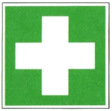 | First responders: pay attention to self-protection!  Symptoms may be delayed.  Remove any clothing contaminated with acetone.  In case of unconsciousness bring to a stable side position and call an ambulance!  After inhalation: Move affected person to fresh air and keep warm and calm.  In case of difficulty in breathing or respiratory arrest initiate artificial respiration. If irritated, seek medical attention.  After eye contact: In case of contact with eyes, rinse immediately with plenty of flowing water for 10 to 15 minutes with open eyelid and consult an ophthalmologist. Protect the injured eye. Remove any existing contact lenses if possible.  Continue rinsing.  After skin contact: In case of contact with skin, wash immediately with plenty of soap and water. Take off dirty, soaked clothes immediately. For skin reactions, consult a doctor.  Ingestion: After swallowing, rinse mouth with plenty of water (only if conscious) and seek medical attention immediately

Tests - Maintenance - Disposal
Dispose of emptied containers and unusable acetic acid by disposing of chemicals at the university.

Signatures
Supervisor: Signature:

Town: Date:

