 |  |  | Operating instructions | 

Work - Equipment - Apparatus - Device
Acetic acid

Dangers for humans and the environment
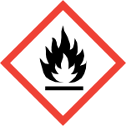  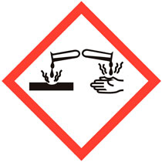 |  | Signal word Danger!  Hazard statements (H-phrases)  • H226 Flammable liquid and vapor.  • H314 Causes severe skin burns and eye damage.  Safety instructions (P-phrases)  • P280 Wear protective gloves / protective clothing / eye protection / face protection.  • P301 + P330 + P331 IF SWALLOWED: rinse mouth. DO NOT induce vomiting.  • P305 + P351 + P338 IF IN EYES: Rinse cautiously with water for several minutes.  Remove contact lenses ,if possible. Continue rinsing.  • P307 + P310 IF EXPOSURE: Immediately call a POISON CENTER or doctor / physician

Protective measures and rules of conduct
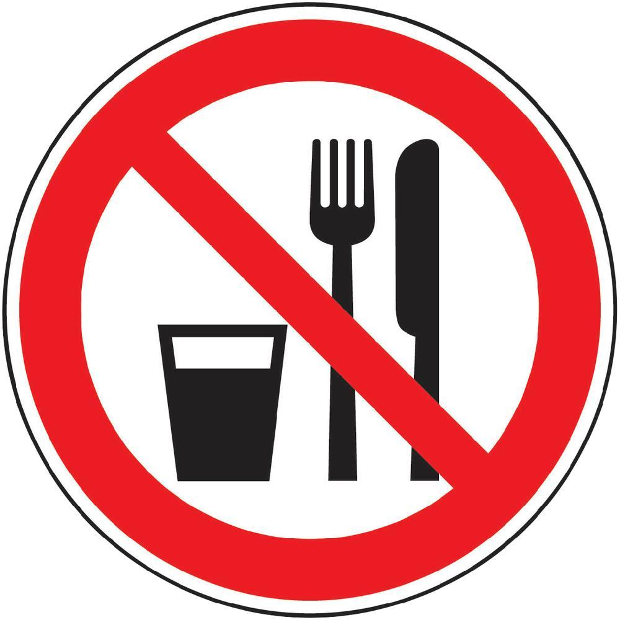  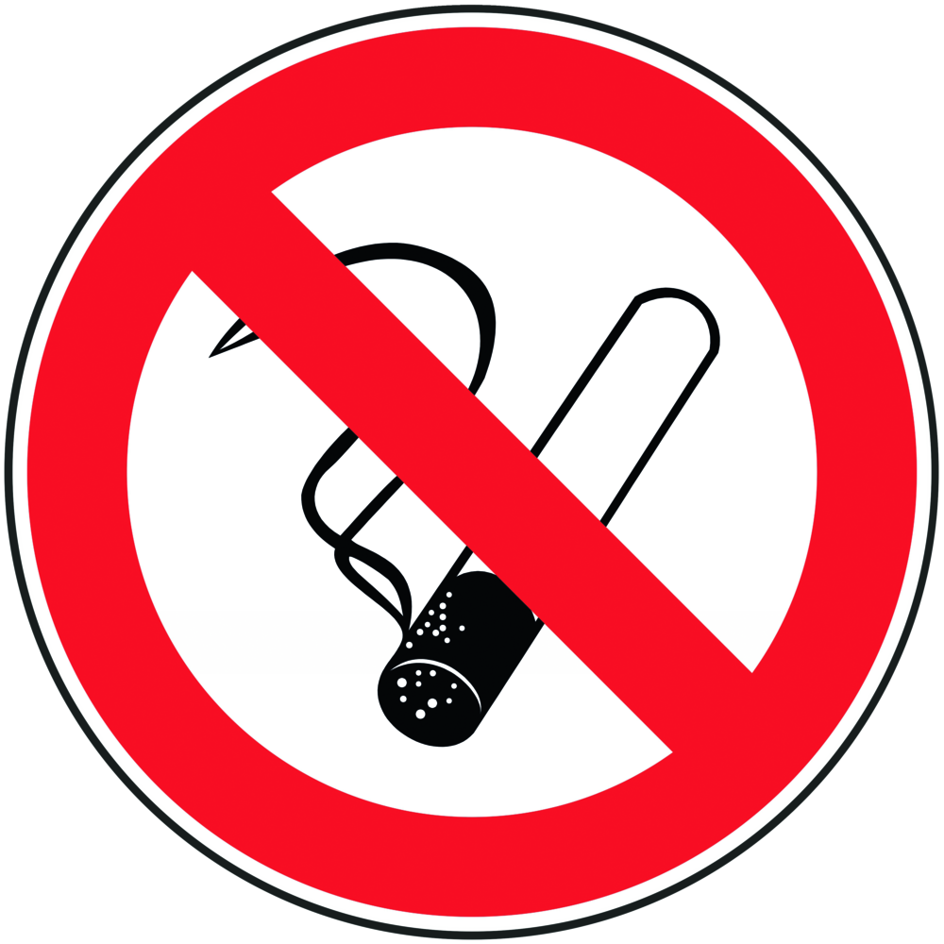 | General information  Eating, drinking or smoking is prohibited in all laboratory facilities!  Avoid contact with eyes and skin.  Keep away from sources of ignition. |  |  |  | - pE
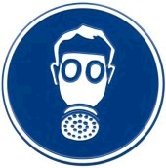
Personal protective measures
Eye protection: Tightly fitting safety goggles.
Hand protection:
Full contact: butyl rubber, thickness 0.7mm
Splash protection: butyl rubber, thickness 0.5mm or natural latex, 0.6mm
Body protection: Lab coat
Respiratory protection: Required if vapors and aerosols are generated.
Respiratory mask: Half mask filter class ABEK (as included in emergency kit MUI)
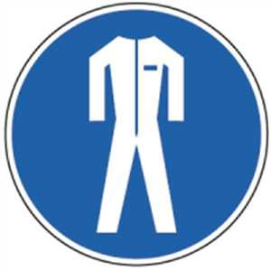

Use and storage
Use:
Keep away from open flames, hot surfaces and sources of ignition.
Take precautionary measures against electrostatic charging.
Change contaminated clothing immediately.
Storage:
Keep container tightly closed in a well-ventilated place
Store at a temperature of + 15 ° C to + 25 ° C.

Transport
Transport of the chemical bottle in the safety bottle container.

Disruptions and Dangers
 | In case of fire:  Suitable extinguishing media: water, carbon dioxide (CO2), foam, extinguishing powder.  Special hazards arising from the substance or mixture: Combustible. Vapors are heavier than air and spread over the floor. When heated, explosive mixtures with air are possible. In case of fire, acetic acid vapors can be released.  Wear an ambient air-dependent respiratory protective device.  After spilling: Do not breathe vapor / aerosol. Soak up with chemical absorbent and have it disposed of by the university's chemical disposal facility. Purify with water.

Accidents and First Aid
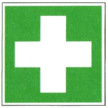 | First responders: pay attention to self-protection!  Symptoms may be delayed.  Remove any clothing contaminated with hydrochloric acid.  After inhalation: fresh air. Get a doctor.  After eye contact: Rinse thoroughly with plenty of water and seek medical advice immediately.  After skin contact: Wash off with plenty of water. Remove soiled, soaked clothing immediately. If available, dab with polyethylene glycol 400. See a doctor.  Ingestion: Drink water (maximum 2 drinking glasses), avoid vomiting  (Perforation). Call a doctor immediately. No neutralization experiments.

Tests - Maintenance - Disposal
Recycle empty containers and unusable TRIS by disposing of chemicals at the university.

Signatures
Supervisor: Signature:

Town: Date:

