 |  |  | Operating instructions | 

Work - Equipment - Apparatus -Device
2 - Mercaptoethanol (Labor)

Dangers for humans and the environment
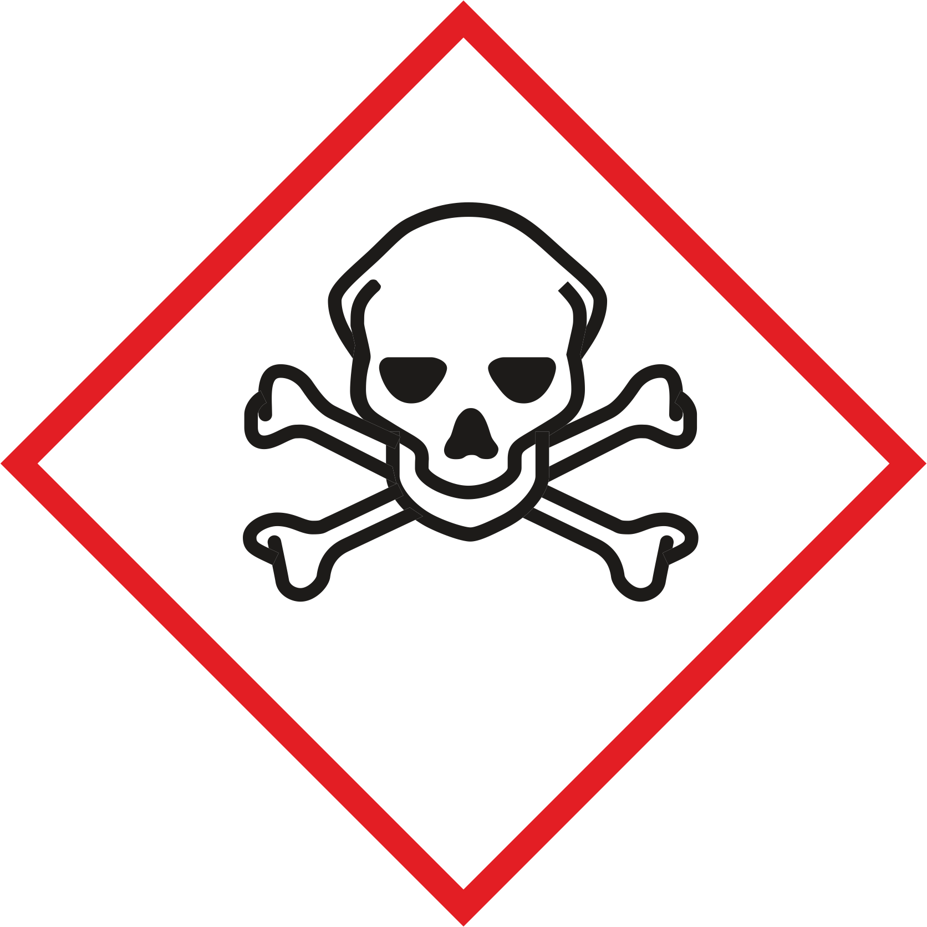  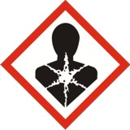  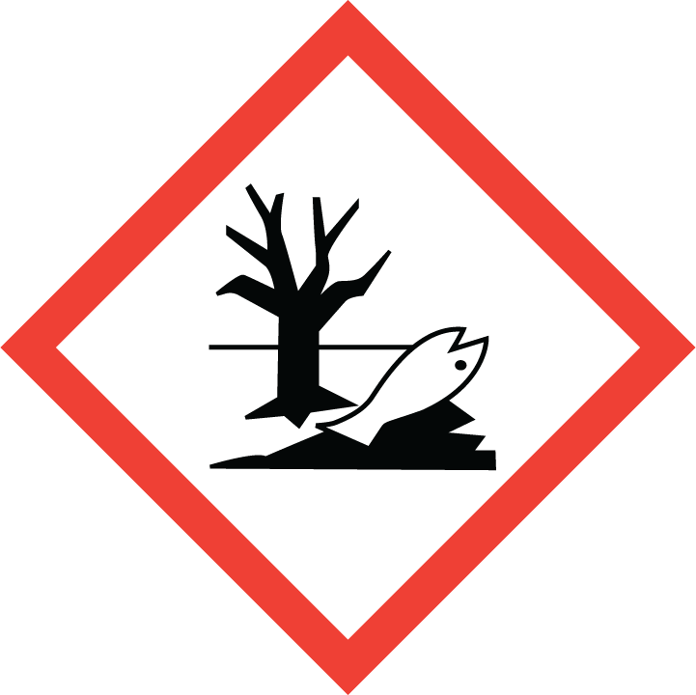  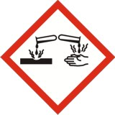 | Toxic if swallowed or if inhaled. (H301 + H331)  Danger to life from skin contact. (H310)  Causes skin irritation. (H315)  Causes serious eye damage. (H318)  May cause an allergic skin reaction. (H317)  May cause damage to organs through prolonged or repeated exposure. (H373)  Very toxic to aquatic life with long lasting effects. (H410)  Inhalation, ingestion or skin contact can lead to health damage. Irritates the skin. Risk of blindness due to burns on the eye! Can cause liver damage in the event of prolonged exposure. May cause nausea, vomiting and loss of consciousness. Can lead to skin allergies.  Danger due to the accumulation of explosive atmospheres near the floor when sprayed or heated! Increased ignition risk with soaked material (e.g. clothing, cleaning cloth). Reacts with strong oxidizing agents with violent heat development. Reacts with acids under violent heat development. Forms with acids in the presence of moisture or water dangerous gases and vapors (hydrogen sulfide). Reacts under violent heat e.g. with certain metals.  Dangerous reactions in the workplace are possible with:  Avoid penetration into soil, water and sewerage!  Protective measures and rules of conduct
Work with dampers or mists in the fume cupboard and keep the front sashes closed. Do not leave vessels open! Avoid splashing and overrun when filling and refilling. Keep reactive substances away or only add them in a controlled manner. Spatial separation and marking of the workplaces. Petting with the mouth is forbidden - use pipetting aids! Use tools that prevent or reduce skin contact. Use tools that prevent or reduce skin contact.
Keep supplies in the laboratory as small as possible and keep them protected against the effects of flame and heat. Avoid spraying or heating, otherwise work in the closed fume cupboard.
Not eating, drinking, smoking or sniffing. Avoid breathing vapors and aerosols! Avoid contact with eyes, skin and clothing! Thoroughly clean hands and other soiled parts of the body after work and before each break. Use skin care products! Immediately remove product residues from the skin, clean the skin gently and dry carefully. Do not wear arm or hand jewelry. Store street clothing separately from work clothing! Change contaminated and soaked work clothes immediately. Use separate cleaning rags and cleaning cloths for skin and machines or devices.
Pay attention to employment restrictions!

Respiratory mask: Half mask filter class ABEK (as included in the MUI emergency kit)
Eye protection: goggles
Hand protection: Gloves from: ... (Please select a suitable protective glove from the Gis-Chem data sheet or other information available to you, taking into account the activity, and indicate this here.) Cotton protective gloves are recommended when wearing protective gloves!
Note the wearing times of protective gloves! If protective gloves are worn for a long time, use special skin protection agents before work.

Disruptions and Dangers

Clear and close the danger area, inform supervisors.
Always wear protective goggles, gloves as well as larger quantities of respiratory protection when cleaning out leaking / spilled product. Suitable respiratory protection: Half mask filter class ABEK (as included in emergency kit MUI). Absorb with absorbent material (e.g., vermiculite, sand) and degas!
Product is combustible. Emergence fire: Use portable fire extinguisher. Not to be used: water in full jet! In the case of fire, hazardous vapors (for example sulfur oxides, carbon monoxide, nitrogen oxides and hydrogen sulphide) are formed! Precipitating vapors with spray water, subsequently as fast as possible cleaning. Danger of bursting when heated.
Observe alarm, escape and rescue plans. Alert fire department.
Occupational Physician: Dr. med. Olaf Riccabona 0512/504 27527 or 0664/5210561
    - Emergency call: 144

Accidents and First Aid
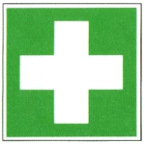 |  | For each first aid measure: pay attention to self-protection, medical treatment. Life-saving immediate measures, such as stable lateral position, cardiopulmonary resuscitation, and shock reduction must be carried out depending on the situation. Cover wounds germ-free. Ensure body peace, protect against heat loss.  After eye contact: Immediately wash (with protection of the uninjured eye) extensively (about 10 minutes) with opened eyelids with water.  After skin contact: Remove uncleaned clothing, also undergarments and shoes, undressed. Rinse skin with plenty of water.  Inhalation: Move injured person out of the danger zone. Immediately, even in the case of missing signs of illness, inhale a dosing aerosol (inhalable solid).  Ingestion: Immediate vigorous rinsing of the mouth. Allow water to drip in small swirls.

Tests - Maintenance - Disposal
Do not pour into spouts or garbage bins!
Collect substance / product waste for disposal in :
Packaging with residual contents:
Dispose of uncleaned absorbent material and cleaning cloths.

Signatures
Supervisor: Signature:

Town: Date:

