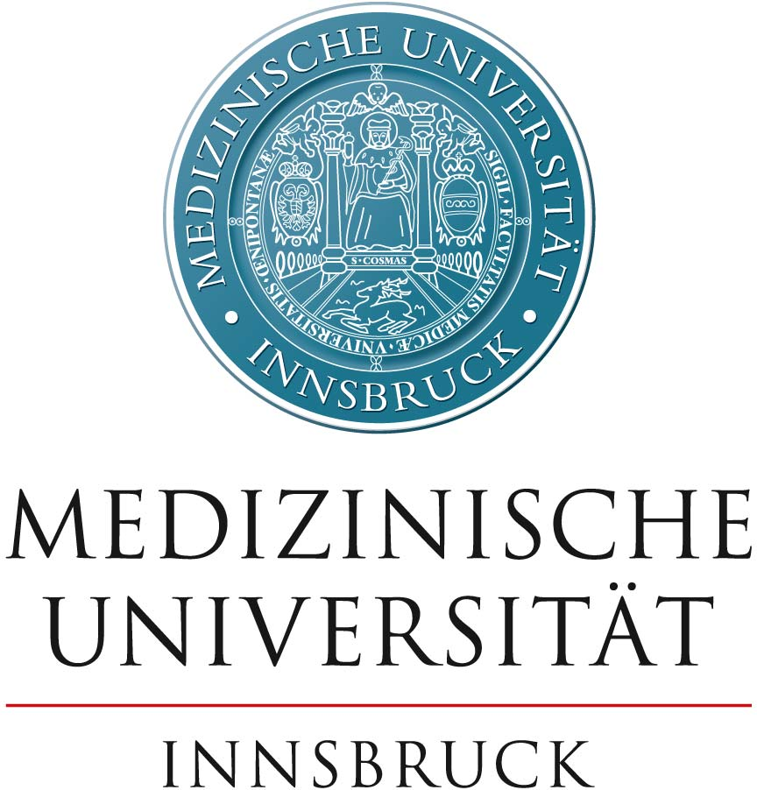
PhD Research Training Group application
Call: MUI-DK-2023
[Geben Sie den Titel ein]

Coordinator:

Consortium members:

Abstract (max. 1 page)
The abstract must containing the following sections:
- Research framework
- Hypotheses/research questions,
- Approach/methods,
- Consortium
- Added value.

Table of Contents
1. Research Framework 4
Introduction, broader research context and overview of the PhD Research Training Group 4
Research topics 4
Innovative potential 4
Quality control procedures 4
Suitability of the PhD Research Training Group for the Innsbruck PHD School of biomedical sciences 4
Ethical aspects 4
Gender aspects affecting the research program 4
2. Description of the participating consortium (Faculty) 4
Profile of the consortium members 4
Gender aspects affecting the consortium composition 5
3. Planned training program 5
Content: 5
Selection of doctoral candidates: 5
Supervision of doctoral candidates and their integration into the research framework: 5
Criteria and assessment procedures to ensure a top-notch doctoral degree: 6
4. Added Value 6
5. Planned dissertation topics 6
6. Requested funding 6
7. References cited 6

1. Research Framework

This section must include all of the following points:

Introduction, broader research context and overview of the PhD Research Training Group

Description of the outstanding scientific research to be conducted in the PhD Research Training Group (objectives, research questions, methods, originality, unique features) with reference to the state of the art in international research.

Research topics
Brief description of the research topics/questions to be addressed by the doctoral candidates for whom funding is requested (a more detailed description of the dissertations topics has to be presented in the section 5: one page/PhD topic).

Innovative potential
Discussion of the scientific advances to be expected from the planned project, its innovative potential, as well as the significance of the resulting research findings for the international scientific community.

Quality control procedures
Presentation of existing procedures or structures to ensure the quality of research as well as the involvement of doctoral candidates in the existing research framework.

Suitability of the PhD Research Training Group for the Innsbruck PHD School of biomedical sciences
Describe here the positioning of PhD Research Training Group within the programs of the Innsbruck PhD School for Biomedical Sciences and how it will contribute to the sustainable establishment of outstanding doctoral research at the MUI.

Ethical aspects

Gender aspects affecting the research program

2. Description of the participating consortium (Faculty)

Profile of the consortium members

Consortium member | Institute
Expertise:

Role and commitment: including the extent of involvement (as percentage of full time employment)
Quality of the consortium member: scientific achievements, international visibility, h index, etc.:
Supervision experience

Gender aspects affecting the consortium composition
Proportion of the researchers from the underrepresented gender. If the percentage is less than 30%, reasons must be provided.

3. Planned training program
The structure of the education and training program as well as procedures for ensuring the quality of scientific supervision of the doctoral candidates must be described in the application. In particular, it must address the following subsections: content, selection of doctoral candidates, supervision.

Content:
- Subject-specific education (content and workload, e.g., number of (required) courses, ECTS credits).
- Opportunities for the acquisition of additional qualifications (transferable skills), for interdisciplinary collaboration, and for the exchange of ideas within the existing doctoral programme (among doctoral candidates, and between candidates and the participating scientific researchers, e.g., journal clubs, retreats, doctoral seminars, lab rotations).

Selection of doctoral candidates:
- Advertisement of the program, and transparent application and selection procedures.
- Process of matching doctoral candidates to supervisors.

Supervision of doctoral candidates and their integration into the research framework:
- Rules on supervision, monitoring, and assessment (e.g., in the form of dissertation agreements, regular progress reports, tandem supervision instead of exclusively individual supervision) as well as conflict resolution mechanisms.
- Support for international networking and promotion of mobility, including opportunities for research visits abroad (over several months), conference attendance, lab visits, invitations to visiting researchers etc...
- Working conditions available infrastructure and any special equipment or facilities at the institute.

Criteria and assessment procedures to ensure a top-notch doctoral degree:
- Requirements for completion (content-related).
- Assessment procedures.

4. Added Value
Please describe:
- The unique characteristics of the proposed PhD Research Training Group (research and training).
- The specific added value for the doctoral candidates and the consortium.

5. Planned dissertation topics
Please use one page per each proposed dissertation topic. The page must include the following information:
- Dissertation topic title
- Research questions/ hypotheses
- Approach/methods
- Supervisor(s) and interaction with other consortium members

6. Requested funding

The MUI can only fund personal costs for six to twelve PhD positions. For training costs and consumables, the maximal amount per PhD position and year is 10.000 €.

7. References cited

