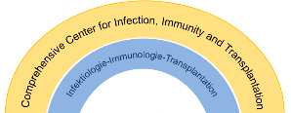
CIIT Science Day 2024
Name: Klicken oder tippen Sie hier, um Text einzugeben.
Type of presentation: Poster ☐ Oral ☐
Abstract title
Klicken oder tippen Sie hier, um Text einzugeben.
Authors
Klicken oder tippen Sie hier, um Text einzugeben.
Affiliations
Klicken oder tippen Sie hier, um Text einzugeben.
Abstract (maximum of 300 words)
Klicken oder tippen Sie hier, um Text einzugeben.

